AutoRestTest
An AI-Powered Collaborative Platform for Automated REST API Testing

SE 801
Software Project Lab 3 Technical Report

Submitted by:
Mohammad Ismail Hossain
Roll: BSSE 1433
Institute of Information Technology
University of Dhaka

Supervised by:
Toukir Ahammed
Lecturer
Institute of Information Technology
University of Dhaka

Submitted to:
SPL-3 Program Committee

Submission Date: 02-08-26

Table of Contents
1. Project overview 5
1.1 Project Title 5
1.2 Problem Statement 5
1.3 Objectives 5
1.4 Scope 6
1.5 Deliverables 6
2. Requirements Analysis 7
2.1 Quality Function Deployment 7
2.1.1 Normal Requirements 7
Functional Requirements 7
Non-Functional Requirements 7
2.1.2 Expected Requirements 7
Functional Requirements 7
Non-Functional Requirements 8
2.1.3 Exciting Requirements 8
Functional Requirements 8
Non-Functional Requirements 8
2.2 Stakeholders 8
2.3 Usage Scenario 9
2.3.1 Authentication System 9
2.3.2 Project Management 9
2.3.3 API Specification Management 9
2.3.4 Test Suite Management 10
2.3.5 Test Execution 10
2.3.6 Test Results and Reports 11
2.3.7 Team Collaboration 12
3. System Modeling 12
3.1 Use Case Diagrams 12
3.1.1 Level 0 — AutoRestTest Overview 12
3.1.2 Level 1 — Full System 13
3.1.3 Level 1.1 — Authentication system 14
3.1.4 Level 1.2 — Project Management 15
3.1.5 Level 1.3 — API Specification Management 16
3.1.6 Level 1.4 — Test Suite Management 17
3.1.7 Level 1.5 — Test Execution 18
3.1.8 Level 1.6 — Test Results & Reports 19
3.1.9 Level 1.7 — Team Collaboration 20
3.2 Activity Diagrams 22
3.2.1 Authentication system 22
3.2.2 Project Management 23
3.2.3 API Specification Management 24
3.2.4 Test Suite Management 25
3.2.5 Test Execution 26
3.2.6 Test Results & Reports 27
3.2.7 Team Collaboration 28
4. Data Modeling 29
4.1 ER Diagram 29
4.2 Database schema 29
5. AI Engineering Design 32
5.1 AI Pipeline 32
5.2 Model Selection 34
5.3 Prompt Design 35
6. User Manual & User Interface 36
6.1 Introduction 36
6.2 System Requirements 36
6.3 Accessing AutoRestTest 36
6.4 Creating an Account 37
6.5 Logging In 39
6.6 The Application Layout 41
6.7 Projects 41
6.8 Project Roles and Permissions 43
6.9 Project Overview Tab 44
6.10 API Specification 44
6.11 Endpoints 46
6.12 Dependency Graph 47
6.13 Test Suites 48
6.14 Captured Requests and Live Request Runs 51
6.15 Team and Collaboration 52
6.16 Account Settings 54
6.17 Logging Out 55
6.18 Frequently Asked Questions 55
7. Test Report 57
Module 1: Authentication system 57
Module 2: Project Management 61
Module 3: API Specification Management 62
Module 4: Test Suit Management 67
Module 5: Test Execution 68
Module 6: Test Results & Reports 70
Module 7: Team Collaboration 72
Steps: 74
8. Real-World Evaluation 75
8.1 Overview 75
8.1 Evaluation Methodology 75
8.3 Evaluation Summary 75
8. Timeline 77
9. Conclusion 78
10. References 78

List of Figures
Figure 1: Use case diagram — Level 0: AutoRestTest system overview 11
Figure 2: Use case diagram — Level 1: Full system 12
Figure 3: Use case diagram — Level 1.1: Authentication 13
Figure 4: Use case diagram — Level 1.2: Project & Endpoint Management 14
Figure 5: Use case diagram — Level 1.3: API Specification Management 15
Figure 6: Use case diagram — Level 1.4: Test Suite Management 16
Figure 7: Use case diagram — Level 1.5: Test Execution 17
Figure 8: Use case diagram — Level 1.6: Test Results & Reports 18
Figure 9: Use case diagram — Level 1.7: Team Collaboration 19
Figure 10: Activity diagram — Authentication 20
Figure 11: Activity diagram — Project & Endpoint Management 21
Figure 12: Activity diagram — API Specification Management 22
Figure 13: Activity diagram — Test Suite Management 23
Figure 14: Activity diagram — Test Execution 24
Figure 15: Activity diagram — Test Results & Reports 25
Figure 16: Activity diagram — Team Collaboration 26
Figure 17: Entity Relationship Diagram 27
Figure 18: AI system workflow diagram 32
Figure 18: Timeline (Gantt Chart) 36

1. Project overview

1.1 Project Title
AutoRestTest: An AI-Powered Platform for Automated REST API Testing

1.2 Problem Statement
As modern web services increasingly rely on REST APIs, ensuring their correctness is critical. As APIs grow in size and complexity, testing them becomes progressively harder because of large input spaces, interdependent operations, and the need for valid request sequences. Traditional automated testing tools often fail to explore these dependencies effectively, leading to low coverage, missed edge cases, and weak fault detection, while manual testing is time-consuming, repetitive, error-prone, and unable to scale with continuous development. Recent research such as AutoRestTest [1] shows that dependency-aware, reinforcement-learning and LLM-powered test generation can substantially improve coverage and fault detection for REST APIs. At the same time, development teams need a centralized, collaborative environment in which specifications, test suites, execution results, and reports can be stored, shared, and reused over time. Existing solutions rarely combine an intelligent testing engine with such a platform, and this gap is the problem this project addresses.

1.3 Objectives
The main objectives of this project are as follows:
- To design and develop an AI-powered, collaborative SaaS platform for automated REST API testing, accessible through a centralized web dashboard.
- To integrate an intelligent testing engine that uses dependency-aware, reinforcement-learning and LLM-based request generation, inspired by the AutoRestTest [1] approach, to maximize coverage and fault detection.
- To allow users to upload OpenAPI specifications, or generate them with AI-assisted analysis, and to extract their endpoints automatically.
- To automatically generate, save, and reuse test suites for each project.
- To provide one-click, asynchronous test execution with real-time status updates and persistent execution history.
- To present clear results and analytics, including status-code distribution, coverage, and server failures, together with LLM-based failure explanations and exportable PDF/CSV reports.
- To enable secure team collaboration through project sharing and role-based access control.

1.4 Scope
The scope of this project defines the boundaries of the platform and the extent of the functionality it delivers. AutoRestTest is a web-based SaaS application for the functional testing of RESTful web services described by OpenAPI 3.0 specifications. Within this boundary it supports the complete testing workflow through a single centralized dashboard, from user and project management to specification handling, AI-driven test generation and execution, result analysis and reporting, and multi-user collaboration, so that development teams can automate REST API testing and reduce manual effort.
Certain areas are intentionally outside the scope of this project. The platform targets REST APIs only and does not address SOAP, GraphQL, or gRPC services, nor specification formats other than OpenAPI 3.0. It focuses on functional and fault-detection testing rather than load, stress, or performance testing, and it does not modify, deploy, or manage the systems under test. The platform further assumes that the target API is reachable over the network and that any credentials required to access protected endpoints are provided by the user.

1.5 Deliverables
The main deliverables of this project are as follows:
- A deployed web application (frontend and backend) that provides the AutoRestTest platform through a centralized, browser-based dashboard.
- An AI-powered testing engine, deployed as an independent service, that performs dependency-aware, reinforcement-learning and LLM-based test generation and execution.
- A PostgreSQL database implementing the platform's data model for users, projects, specifications, test suites, executions, results, and collaboration.
- A complete, documented source-code repository covering the frontend, backend, and testing engine.
- This technical report, documenting the project's overview, requirements, system and data models, AI engineering design, preliminary test plan and timeline.

2. Requirements Analysis

2.1 Quality Function Deployment

2.1.1 Normal Requirements
Explicitly requested core features; user satisfaction is proportional to how well they are met.

Functional Requirements
- FR-N1 — User Authentication: register, log in, and maintain secure sessions.
- FR-N2 — Project Management: create, open, rename, and delete API testing projects from a central dashboard.
- FR-N3 — Specification Upload: upload an OpenAPI 3.0 file; the system parses it and lists the extracted endpoints.
- FR-N4 — Test Execution: run automated requests against the target API from a specification and collect the responses.
- FR-N5 — Result Viewing: view each run's outcome per endpoint (method, request, response, status code, pass/fail).
- FR-N6 — Completion Notifications: notify the user when a run completes, fails, or errors.

Non-Functional Requirements
- NFR-N1 — Usability: the whole workflow is driven from one intuitive web dashboard, usable without special training.
- NFR-N2 — Responsiveness: routine interactions (dashboard, navigation) load within a couple of seconds.

2.1.2 Expected Requirements
Implicitly assumed; their absence causes dissatisfaction even though users rarely ask for them by name.

Functional Requirements
- FR-E1 — Automatic Test Suite Generation: automatically generate a comprehensive, dependency-aware suite of test cases from the specification.
- FR-E2 — Save & Reuse Suites: persist named test suites for re-execution without reconfiguration.
- FR-E3 — Execution History: keep every past run with its timestamp and outcome for later review.
- FR-E4 — Reports & Analytics: per-run summary of HTTP status-code distribution, coverage, and server failures.
- FR-E5 — Export Reports: download a run's results as PDF or CSV.
- FR-E6 — Team Collaboration: invite members to a project and assign roles (admin, tester, viewer).

Non-Functional Requirements
- NFR-E1 — Security & Data Privacy: passwords hashed, routes JWT-protected, and each user's and project's data isolated via role-based access control.
- NFR-E2 — Reliability: long-running executions run asynchronously without blocking the UI and report status accurately.
- NFR-E3 — Data Persistence: specifications, suites, runs, and results are stored durably and remain available across sessions.

2.1.3 Exciting Requirements
Delighters beyond expectation; their absence isn't penalised, but their presence differentiates the platform.

Functional Requirements
- FR-X1 — One-Click End-to-End Testing: a single action runs the entire pipeline — read spec, generate tests, execute, and produce a report.
- FR-X2 — AI Failure Explanation: LLM-generated, plain-language explanation of what caused a failure and which request triggered it.
- FR-X3 — AI Specification Generation: automatically generate an OpenAPI specification from uploaded source code.

Non-Functional Requirements
- NFR-X1 — Extensibility: the AI testing engine is deployed as an independent service, so its generation strategy can evolve without changing the web platform.

2.2 Stakeholders
The key stakeholders of the platform and their interests are summarised below:
- API Developer: Uploads specifications and runs tests to catch defects in their REST APIs early.
- QA Engineer / Tester: Generates and executes test suites and reviews results and failure explanations.
- Team Lead / Project Manager: Creates projects, invites members, assigns roles, and tracks testing progress.
- Viewer (Client / Stakeholder): Reviews reports and analytics without modifying tests.

2.3 Usage Scenario

2.3.1 Authentication System
The system will have an authentication system with two options: sign up for new users and log in for users who already have an account.
User Sign Up
A new user will begin registration by visiting the platform's sign-up page and clicking the Create Account button. The user will need to provide a valid email address, a username, and a password. The system will validate the uniqueness of the username and email and the format of the email address.
User Login
Already registered users can log in by providing their email address and password on the login page. The system will maintain user sessions securely, allowing users to remain logged in without having to authenticate repeatedly. Users will also have the option to keep their login details saved for quicker access in future sessions.

2.3.2 Project Management
Once logged in, users will be taken to the main dashboard where all their projects are displayed. The system will allow users to create, manage, and organise multiple API testing projects from a single centralised interface.
Create Project
A user can create a new project by clicking the New Project button on the dashboard. The user will provide a project name and an optional description. Once created, the project will appear on the dashboard and the user will be taken to the project workspace where they can begin setting up their testing environment.
Manage Projects
The dashboard will display all projects belonging to the user along with their names, creation dates, and last activity. Users can open, rename, or delete any project from the dashboard. Users can add multiple API endpoints inside a project. Deleting a project will remove all associated specifications, test suites, and results permanently, following a confirmation prompt from the system.

2.3.3 API Specification Management
Before testing can begin, users need to define the API they want to test. Each project may have an API specification. The system will provide two ways to do this: uploading an existing specification file or generating one automatically from source code.
Upload OpenAPI Specification
Users can upload an OpenAPI specification file in .yaml format directly into their project. The system will parse and validate the uploaded file and display the list of detected API endpoints and operations, making them available for test generation. If the file contains errors or is not a valid specification, the system will notify the user with a description of the problem.
Automated API Specification Generation
For users who do not have an existing specification file, the system will provide an option to generate one automatically. The user can upload their API source code files and the system will analyse them to produce a valid OpenAPI specification. The generated specification will be displayed for review before the user proceeds, and it can be used as the basis for testing in the same way as a manually uploaded file.

2.3.4 Test Suite Management
Once an API specification is available within the project, the system will allow users to generate, save, and reuse test suites for repeated testing.
Automatic Test Suite Generation
After a specification is uploaded or generated, the system will automatically produce a comprehensive set of test cases covering the detected API endpoints and operations. The generated test suite will be displayed to the user showing each test case, its target endpoint, and the HTTP method that will be used. Users are not required to write or configure any test cases manually.
Save and Reuse Test Suites
The test suite will be saved for future use. Saved test suites will appear in the project's Test Suites section and can be re-executed at any time without regenerating or reconfiguring them. This is particularly useful for regression testing, where the same suite needs to be run repeatedly after API changes.

2.3.5 Test Execution
When a test suite is executed, the system will send automated requests to the target API, collect the responses, and track the progress in real time.
One-Click API Testing
The system will provide a single Run button that, when clicked, triggers the entire testing pipeline automatically. The system will read the active specification, generate test cases, execute all tests against the target API, and produce a full report — all without requiring any additional input from the user. This allows a team to run a complete API test in a single action.
Running Tests
Users can initiate a test run by selecting a test suite and clicking the Run button. The system will display a live progress indicator showing which endpoints are currently being tested and how many have been completed. Users can monitor the execution as it progresses without needing to refresh the page.
Test Alerts and Notifications
Once a test run is complete, the system will send the user a notification confirming completion along with a brief summary of the outcome. If the run encounters a failure — such as the target API being unreachable, an unexpected server error, or a system-level issue during execution — the user will be notified immediately with a description of what went wrong.

2.3.6 Test Results and Reports
After each test run, the system will store the results and provide detailed reporting and analysis options for the user to review.
Viewing Test Results
Users can open any completed test run to see a full breakdown of the results. The results page will show each endpoint that was tested, the HTTP method used, the response received, and whether the test passed or failed. Users can filter the results by endpoint, response status, or HTTP response code to focus on specific areas of interest. In addition, the system records every individual request the engine sent during the run, so users can inspect the exact request and response captured for each call.
Test Reports and Analytics
The system will generate a summary report for each completed test run showing the distribution of HTTP response codes received across all tested endpoints, any server-side failures that were detected, and the proportion of the API's endpoints that were covered during the run. This gives the team a complete picture of how the API performed.
Test Failure Explanation
When a server-side failure or unexpected response is detected, the system will provide a plain-language explanation describing which request triggered the failure, what response was received, and what the likely cause may be. This reduces the time users spend investigating and diagnosing issues after a test run.
Test Execution History
The system will maintain a complete history of all test runs for each project. Users can access the history from the project workspace and see a list of past executions with their timestamps, the test suite used, and a summary of outcomes. Any past run can be opened to review its full results in the same way as a recent run.
Export Test Reports
Users can download the results and report of any completed test run in standard formats such as PDF or CSV. The exported file will contain the full results breakdown, the analytics summary, and the details of any detected failures, allowing users to share test outcomes with stakeholders or include them in project documentation.

2.3.7 Team Collaboration
The system will allow multiple users to collaborate within a shared project. The project owner can invite team members and assign them roles to control what each member can see and do within the project.
Inviting Team Members
The project owner or an admin can invite other users to join the project by entering their email address. The invited user will receive an invitation with a link to accept it. Once accepted, the user will be added to the project and it will appear on their dashboard.
Role Management
Each team member is assigned a role that determines their level of access. An admin can manage project settings, invite or remove members, and execute test runs. A tester can upload specifications, generate test suites, and run tests. A viewer can only see test results and reports without making any changes to the project. The project owner can update a member's role or remove them from the project at any time.

3. System Modeling

3.1 Use Case Diagrams

3.1.1 Level 0 — AutoRestTest Overview
Primary Actors: User (Owner, Admin, Tester, Viewer)
Secondary Actors: LLM service, AutoRestTest engine, Target REST API, Email service
Goal in Context: High-level view of the AutoRestTest platform, an AI-powered SaaS for automated REST API testing. Shows how users manage projects and specifications, generate and run AI-driven test suites, and review results, while the platform coordinates with external services to fulfil these goals.

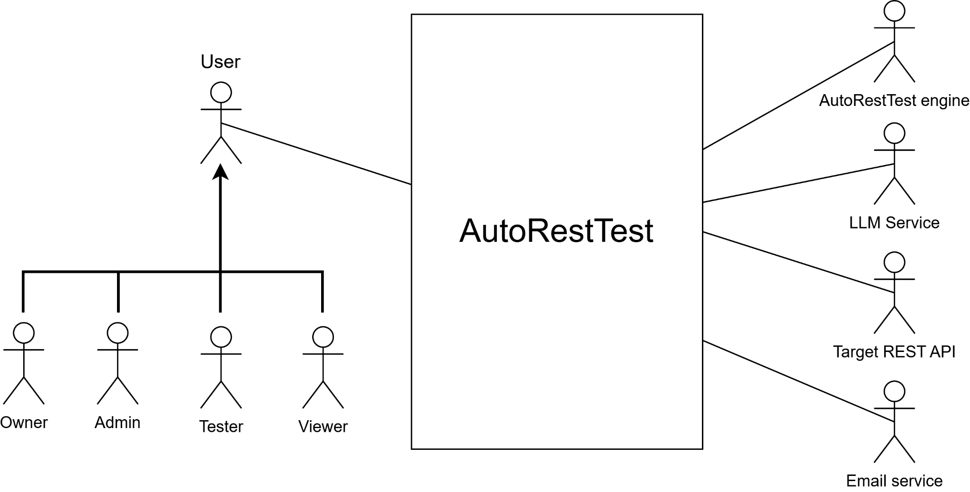
Figure 1: Use case diagram — Level 0: AutoRestTest system overview

3.1.2 Level 1 — Full System
Primary Actors: User (Owner, Admin, Tester, Viewer)
Secondary Actors: LLM service, AutoRestTest engine, Target REST API, Email service
Goal in Context: Expands the overview into all functional areas — authentication, project & endpoint management, specification management, test-suite management, execution, results & reports, and collaboration — showing every major use case and the actors involved.
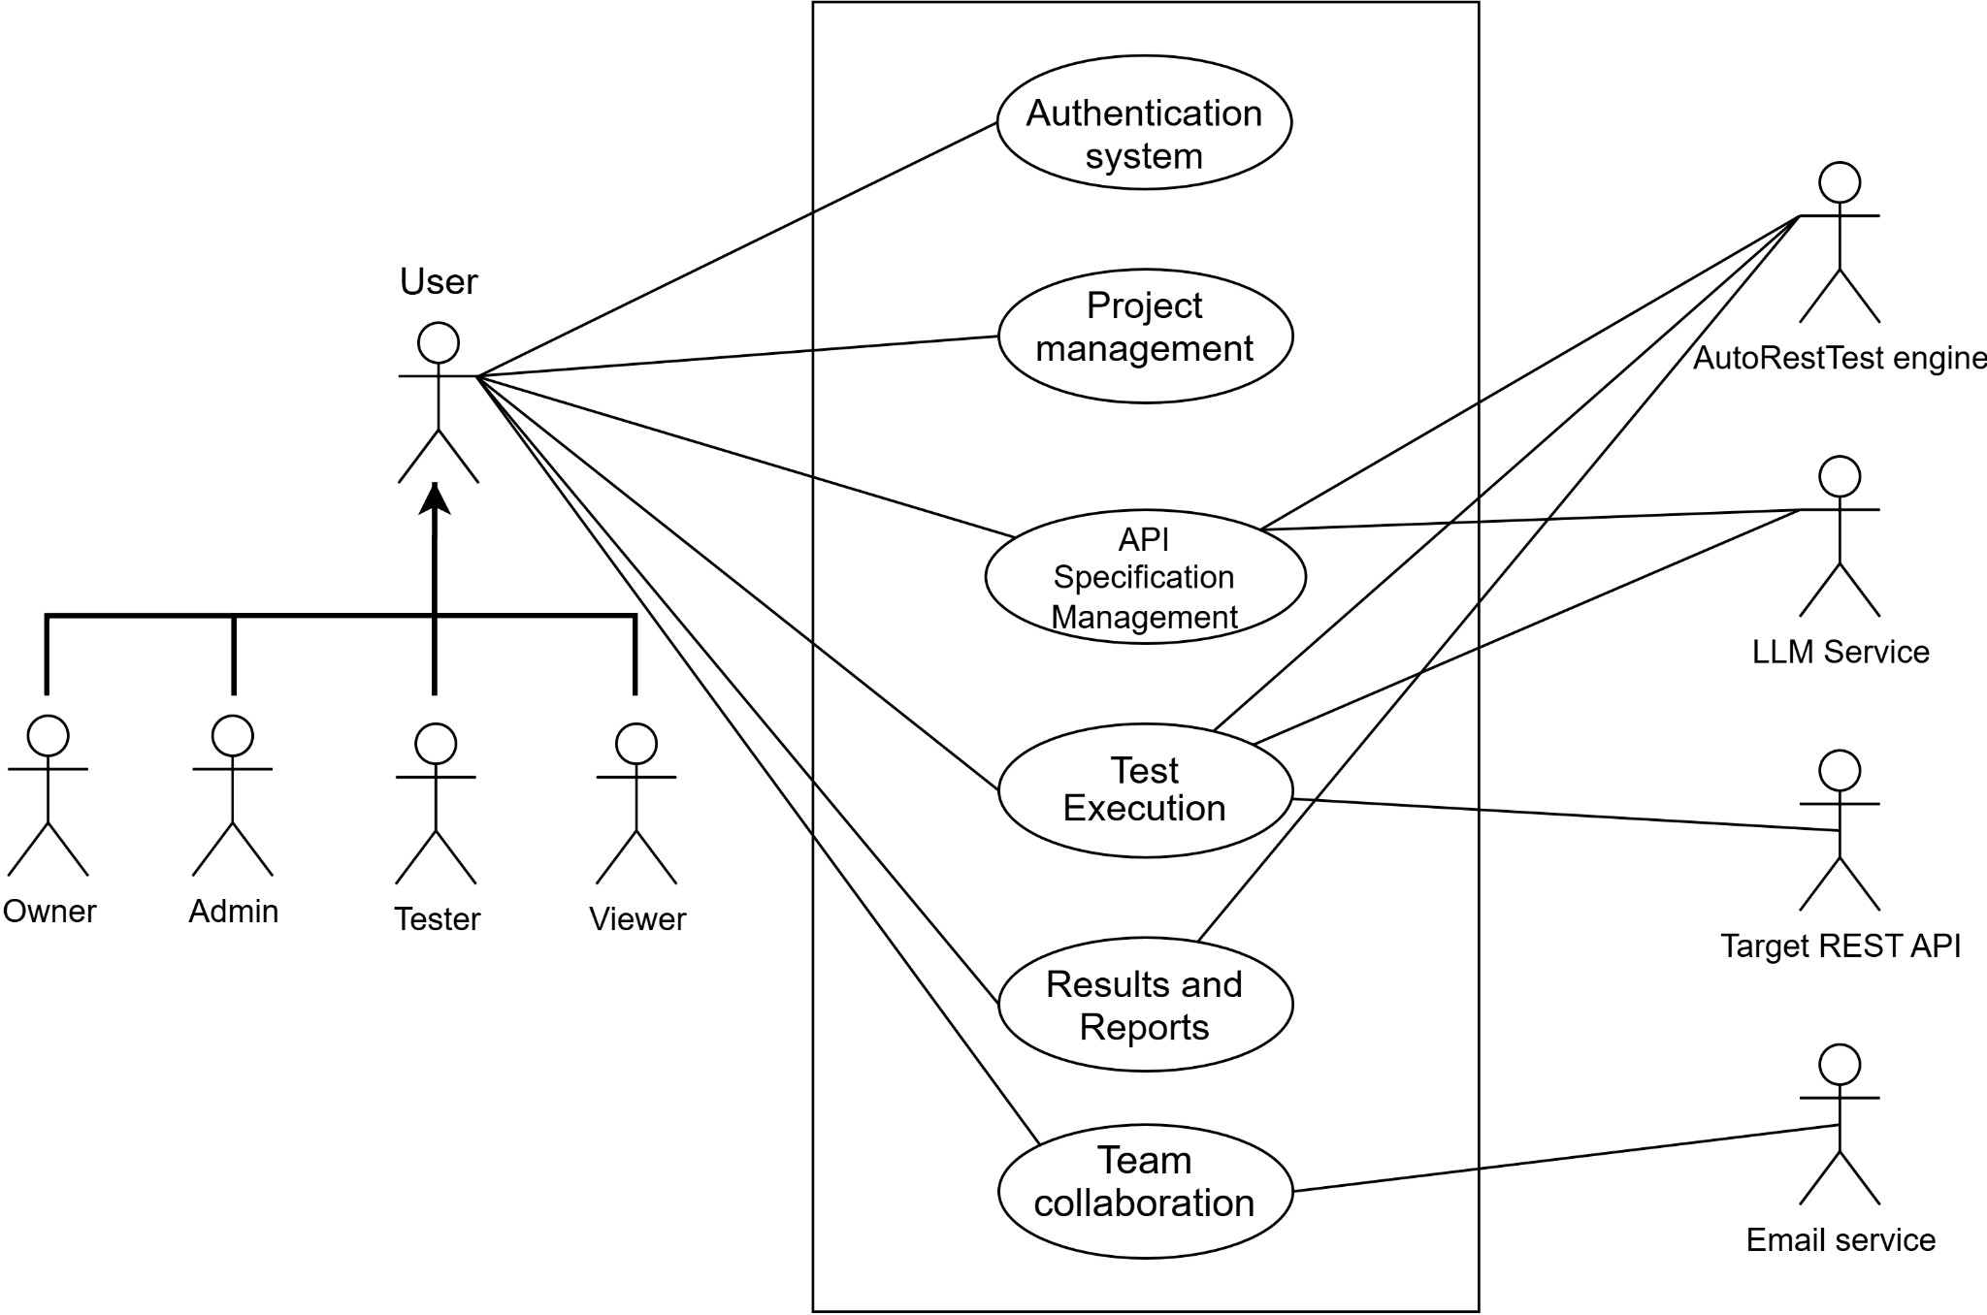
Figure 2: Use case diagram — Level 1: AutoRestTest Full system

3.1.3 Level 1.1 — Authentication system
Primary Actors: user
Secondary Actors: -
Goal in Context: How a user creates an account and authenticates: signing up with a unique email and password, and logging in to obtain a secure session that grants access to the dashboard.

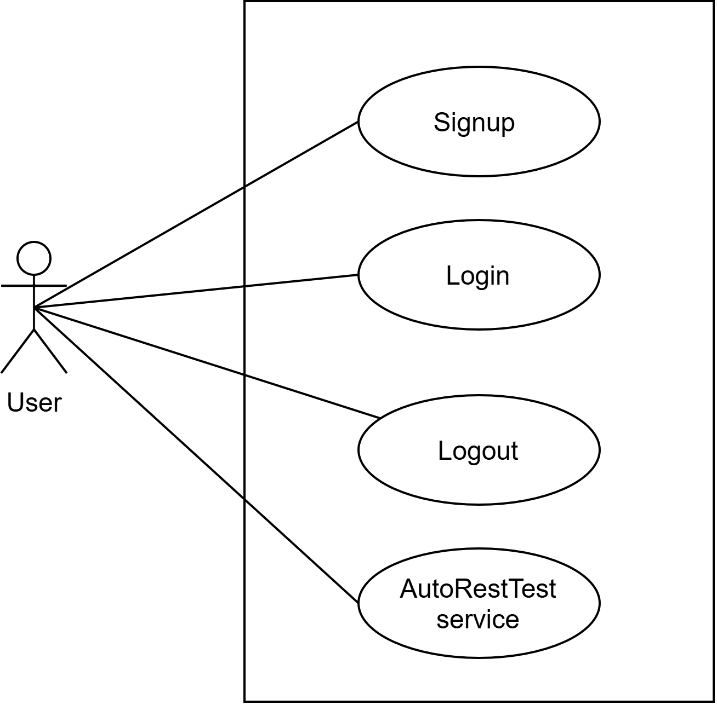
Figure 3: Use case diagram — Level 1.1: Authentication

3.1.4 Level 1.2 — Project Management
Primary Actors: User
Secondary Actors: -
Goal in Context: How an authenticated user creates, opens, renames, and deletes API testing projects from the dashboard, and views the endpoints that belong to a project.

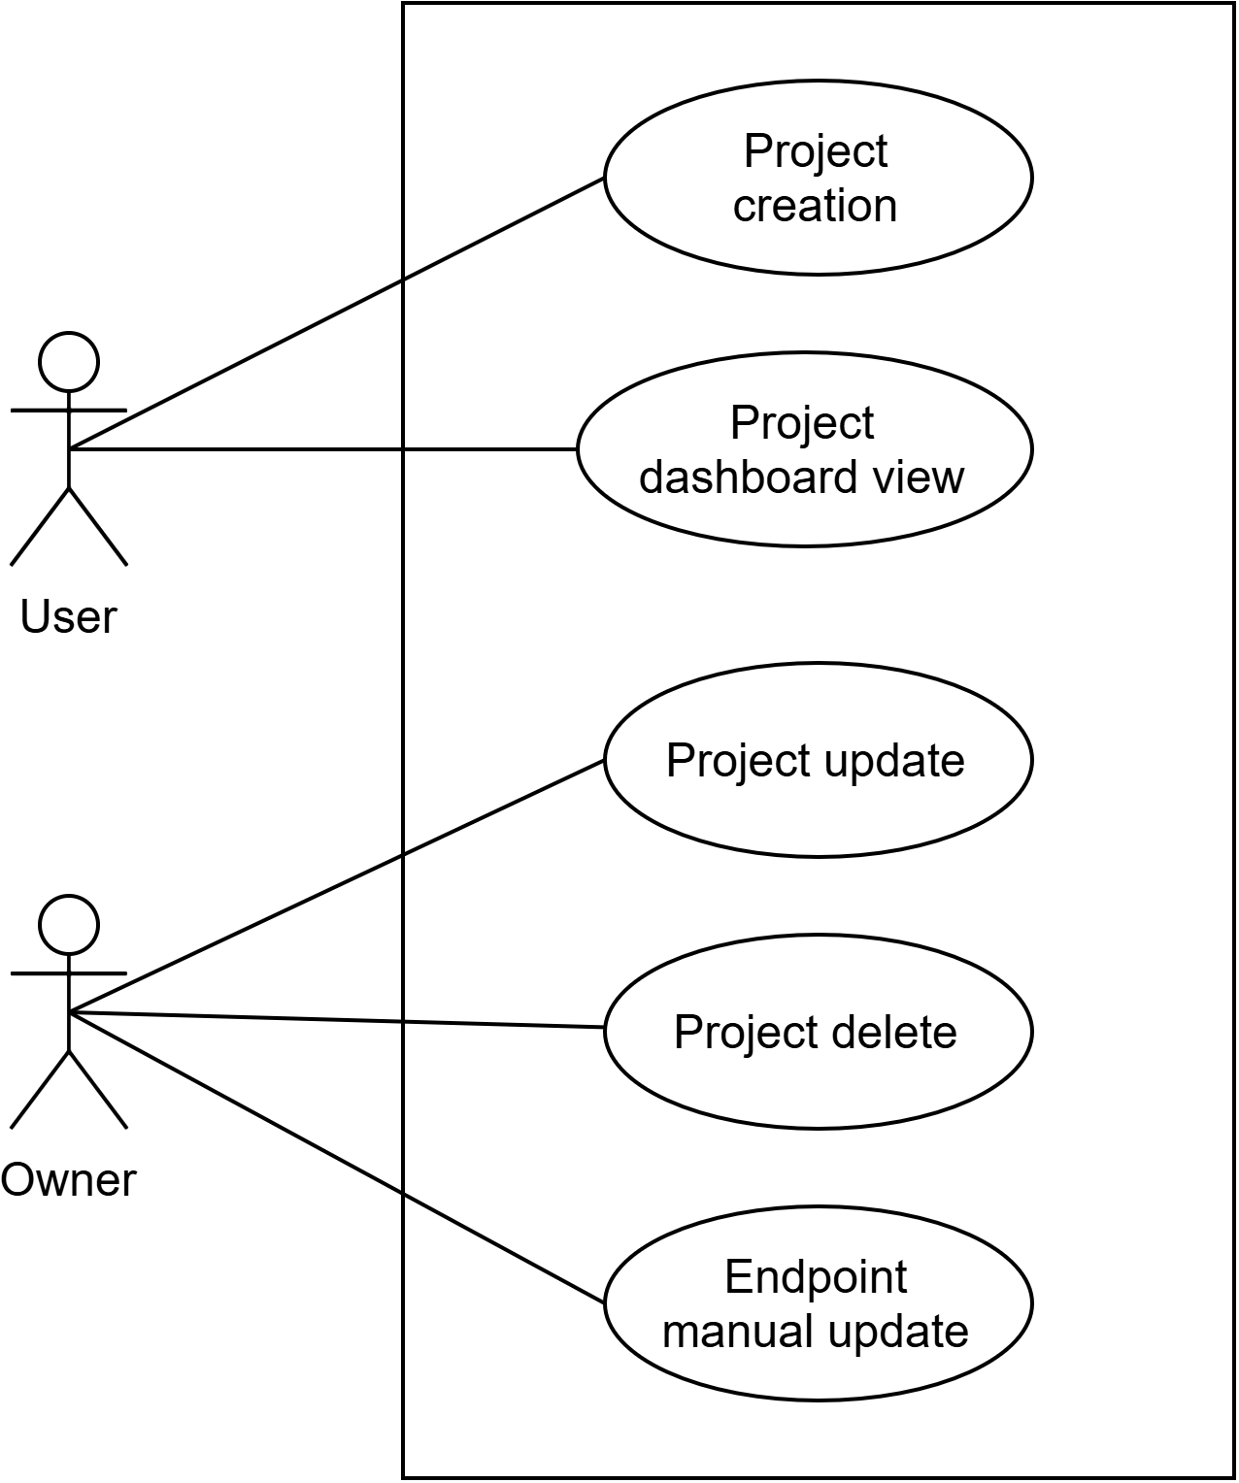
Figure 4: Use case diagram — Level 1.2: Project Management

3.1.5 Level 1.3 — API Specification Management
Primary Actors: User (Admin, Tester, Viewer)
Secondary Actors: LLM service, AutoRestTest engine
Goal in Context: How a user provides the API definition for a project — uploading an OpenAPI 3.0 file that the engine parses to extract endpoints, or generating a specification automatically from source code with AI assistance.

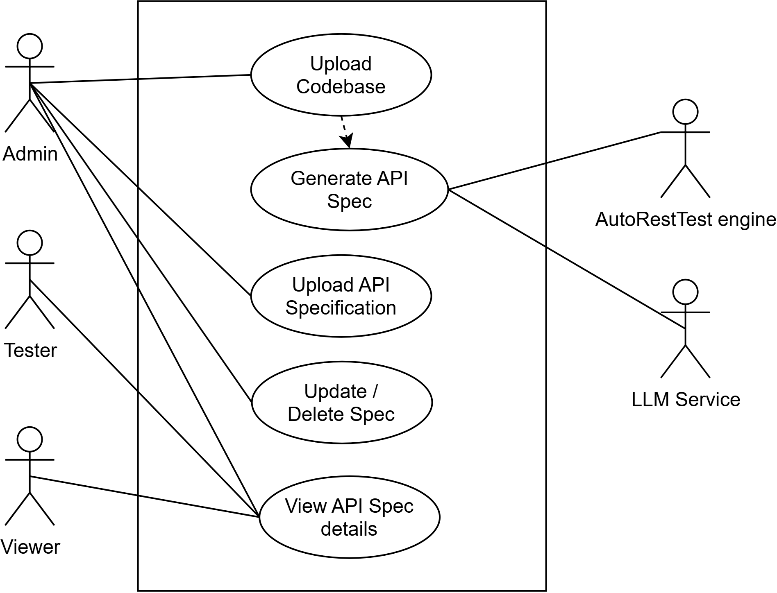
Figure 5: Use case diagram — Level 1.3: API Specification Management

3.1.6 Level 1.4 — Test Suite Management
Primary Actors: User (Admin, Tester, Viewer)
Secondary Actors: LLM service, AutoRestTest engine
Goal in Context: How test suites are produced and managed — automatically generating a comprehensive, dependency-aware suite from the specification, and saving named suites for reuse.

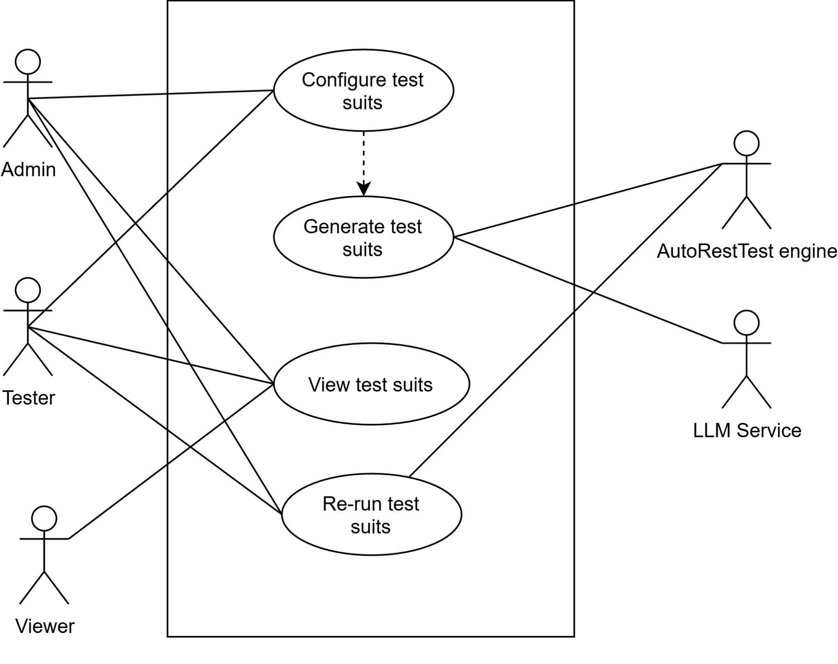
Figure 6: Use case diagram — Level 1.4: Test Suite Management

3.1.7 Level 1.5 — Test Execution
Primary Actors: User (Admin, Tester, Viewer)
Secondary Actors: LLM service, AutoRestTest engine, Target REST API, Email service
Goal in Context: How a user runs a test suite: the platform creates an asynchronous job, the engine sends generated requests to the target API and records responses, and the user is notified when the run completes.

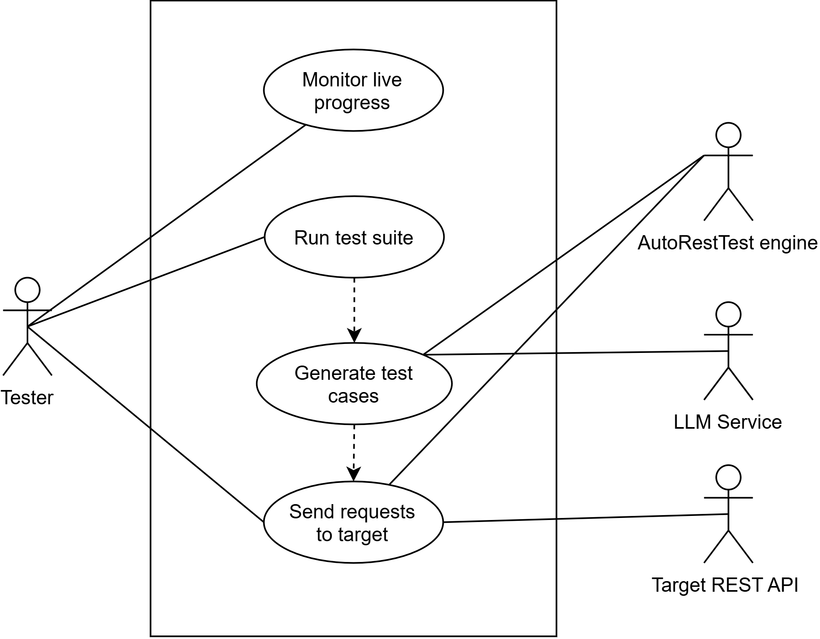
Figure 7: Use case diagram — Level 1.5: Test Execution

3.1.8 Level 1.6 — Test Results & Reports
Primary Actors: User (Admin, Tester, Viewer)
Secondary Actors: LLM service
Goal in Context: How a user reviews a run — per-endpoint results, analytics (status-code distribution, coverage, failures), AI failure explanations, execution history, and exporting reports as PDF/CSV.

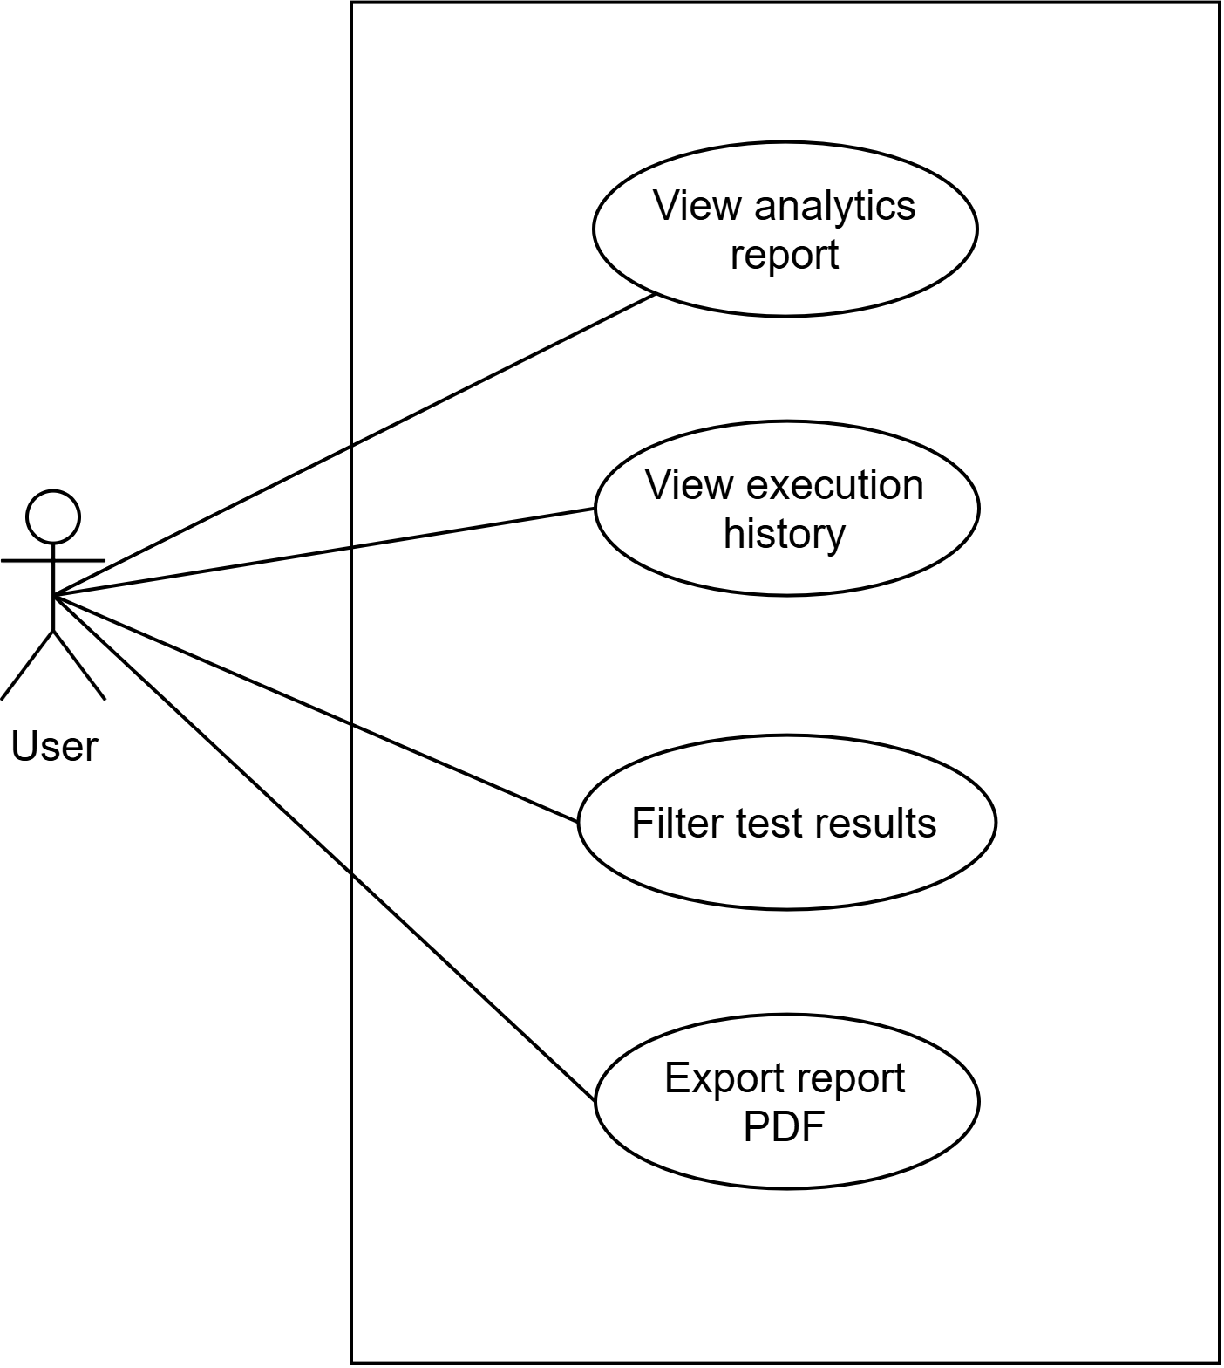
Figure 8: Use case diagram — Level 1.6: Test Results & Reports

3.1.9 Level 1.7 — Team Collaboration
Primary Actors: User (Admin, Tester, Viewer)
Secondary Actors: Email service
Goal in Context: How the project owner invites members by email and assigns roles (admin, tester, viewer), with role-based access controlling what each member can do.
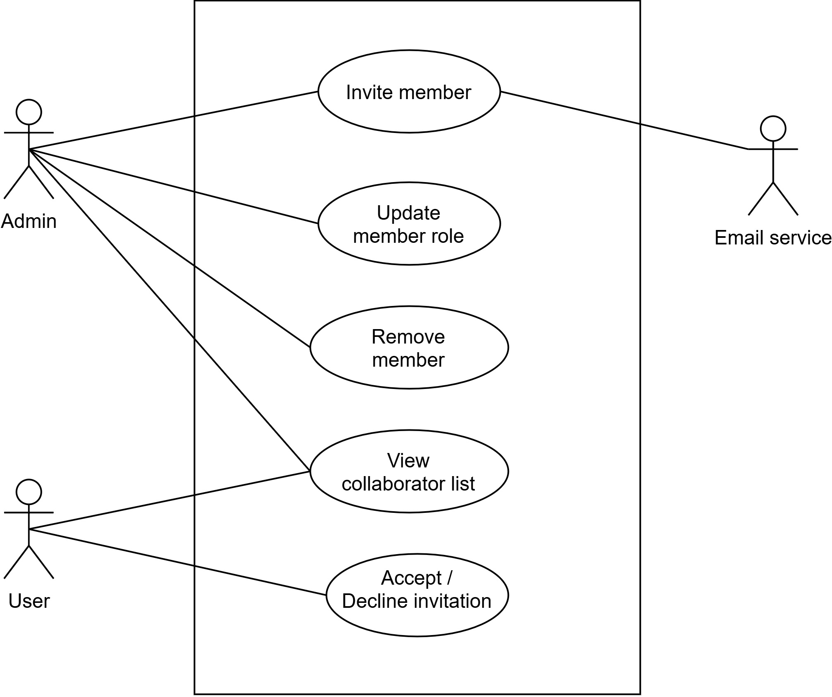
Figure 9: Use case diagram — Level 1.7: Team Collaboration

3.2 Activity Diagrams

3.2.1 Authentication system
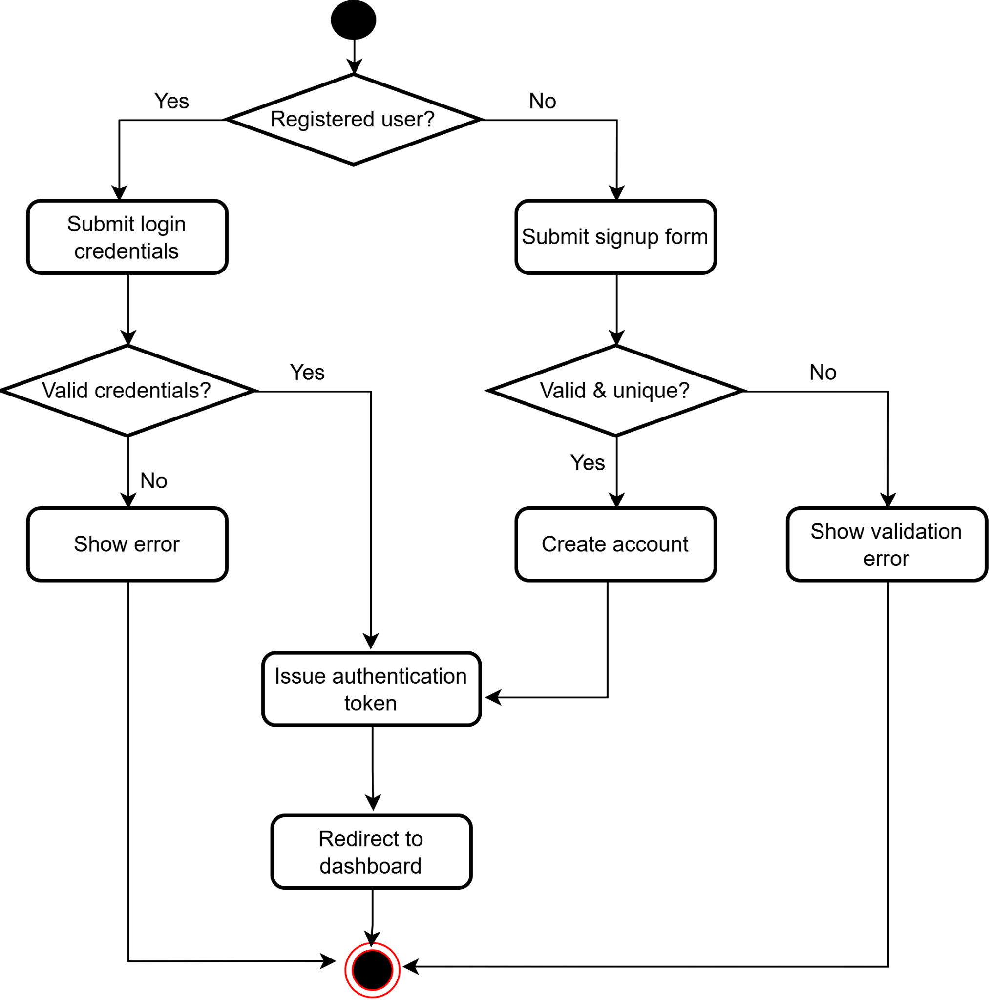
Figure 10: Activity diagram — Authentication

3.2.2 Project Management
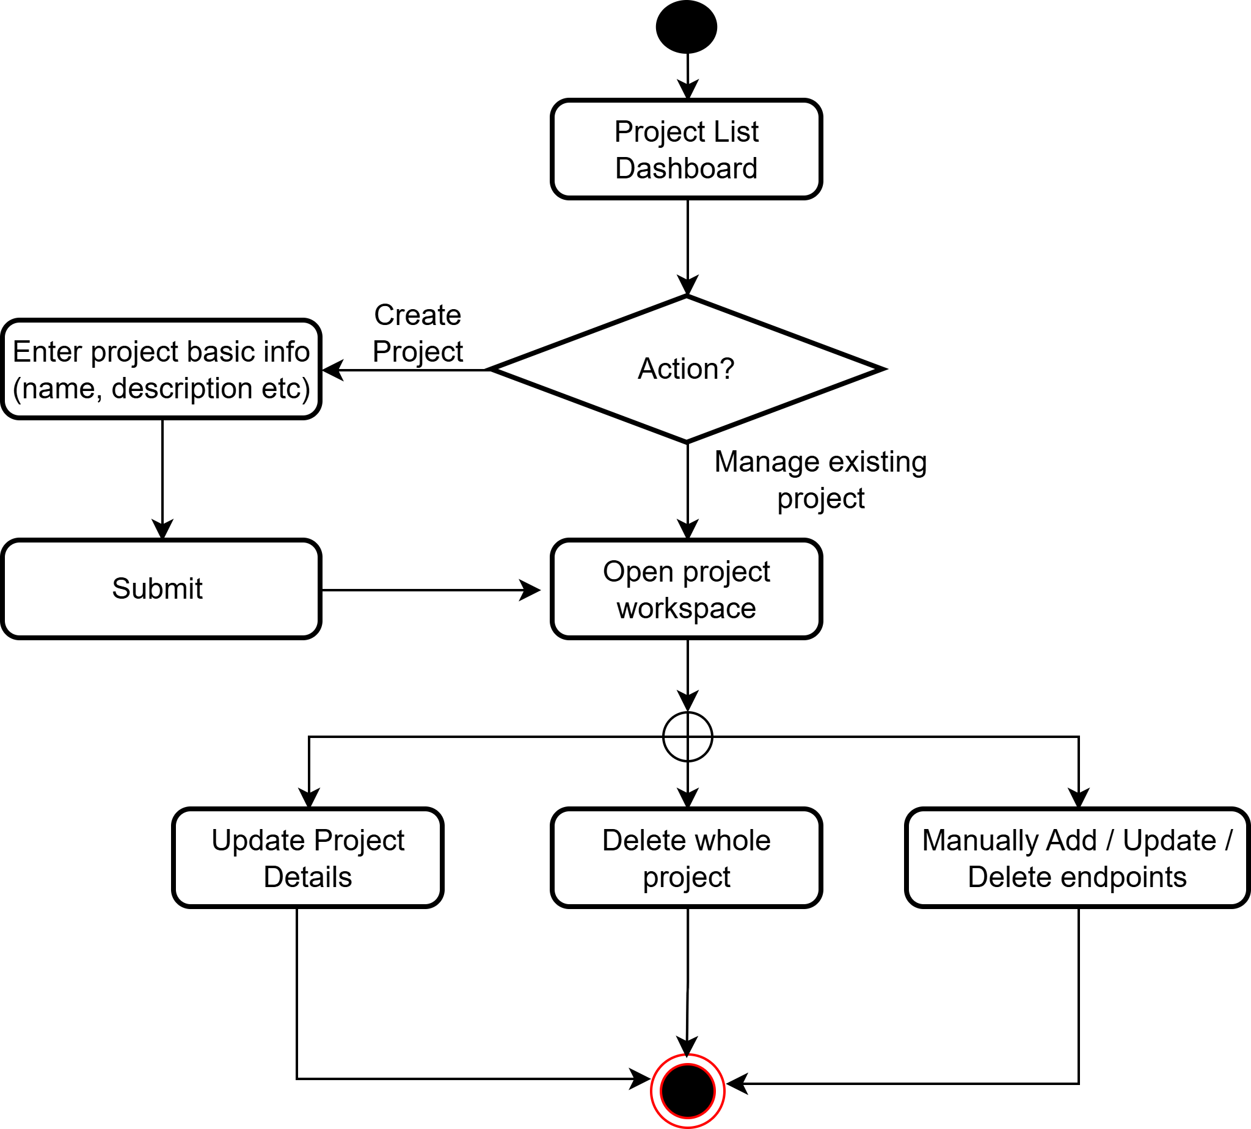
Figure 11: Activity diagram — Project Management

3.2.3 API Specification Management
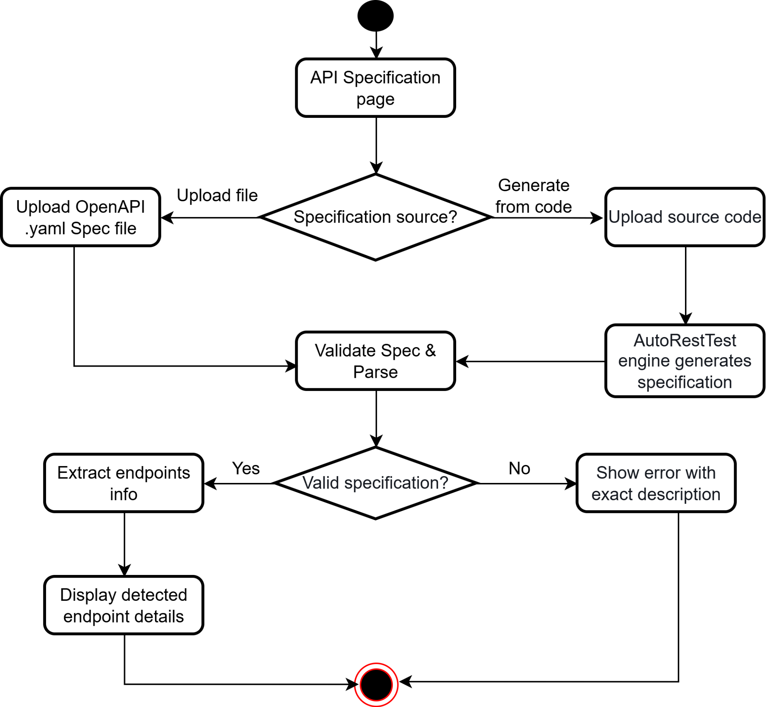
Figure 12: Activity diagram — API Specification Management

3.2.4 Test Suite Management
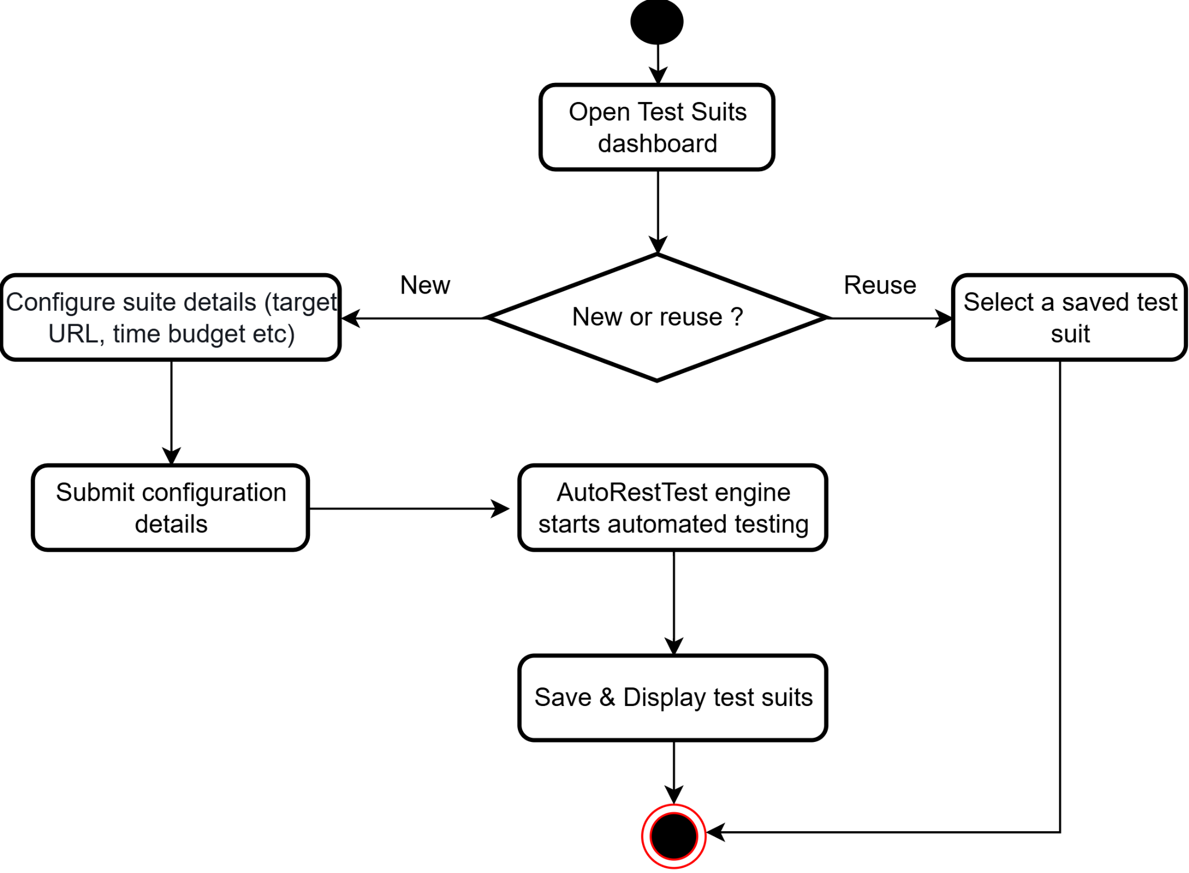
Figure 13: Activity diagram — Test Suite Management

3.2.5 Test Execution
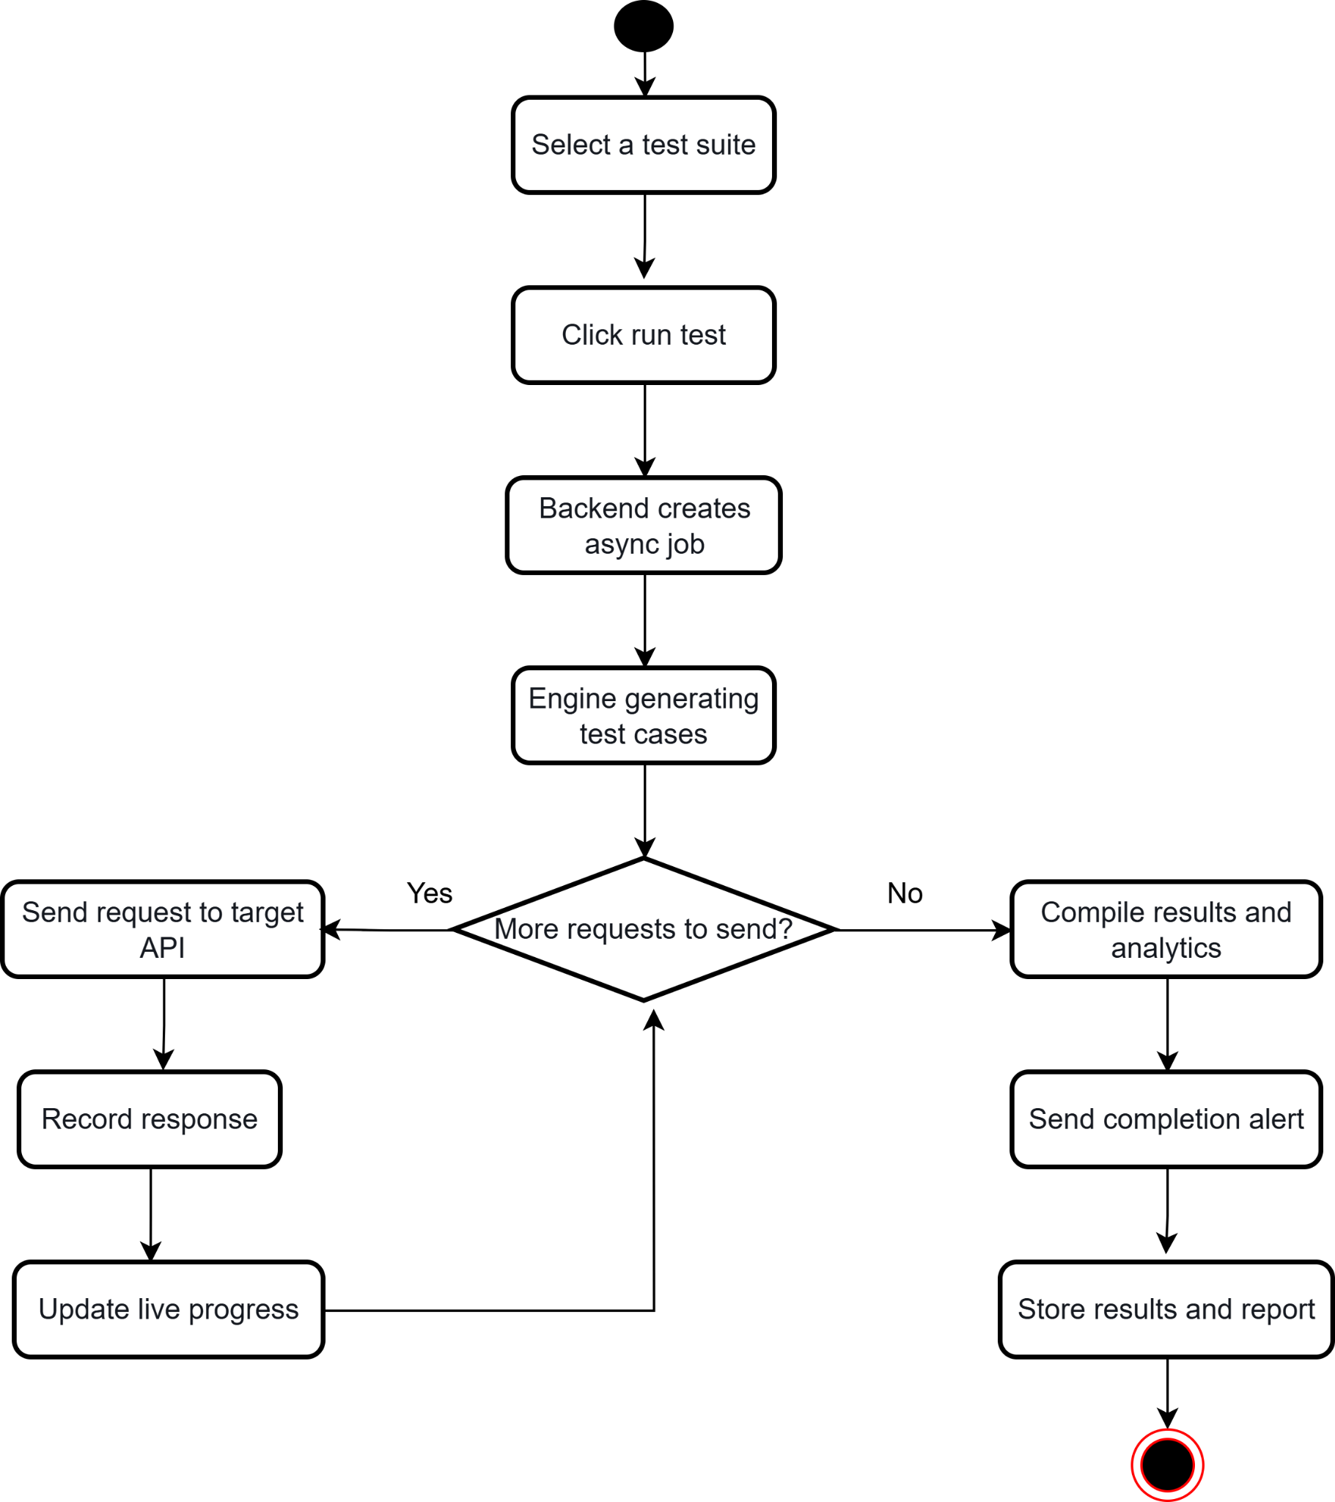
Figure 14: Activity diagram — Test Execution

3.2.6 Test Results & Reports
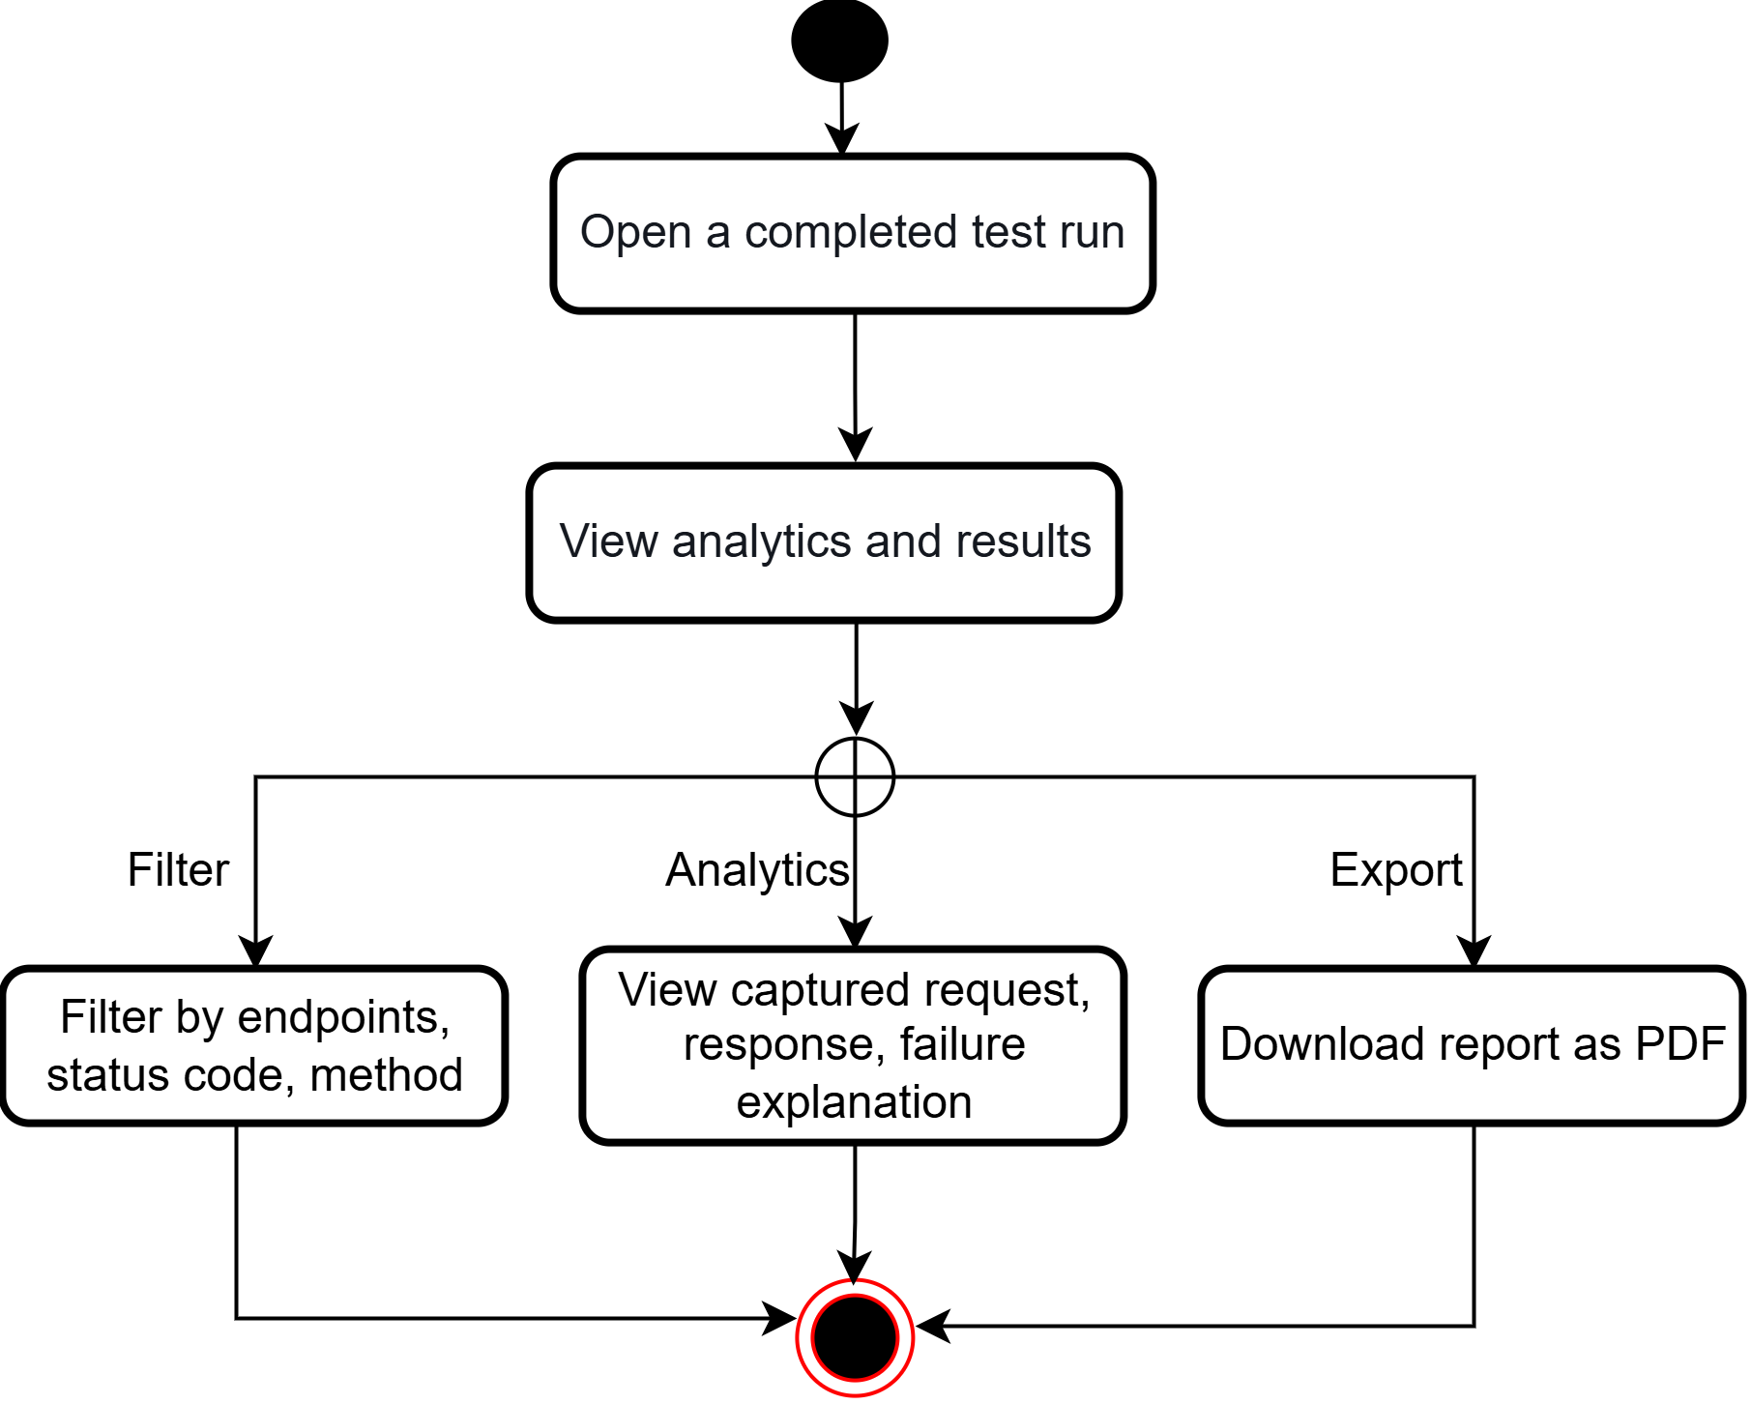
Figure 15: Activity diagram — Test Results & Reports

3.2.7 Team Collaboration
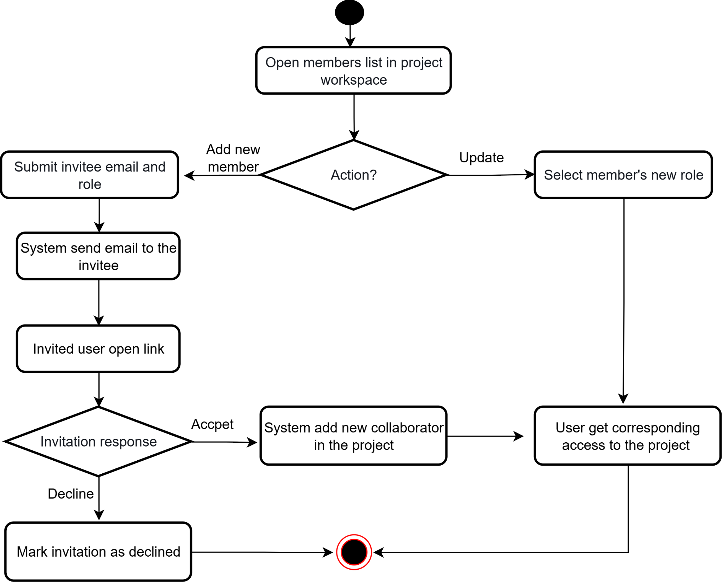
Figure 16: Activity diagram — Team Collaboration

4. Data Modeling
Database modeling describes how the platform's persistent data is structured and related. AutoRestTest uses a relational schema on PostgreSQL, accessed through the Prisma ORM. The model comprises nine entities and four enumerated types.

4.1 ER Diagram
Entity Relationships:
- A User can own many Projects.
- A User can belong to many Projects through ProjectMember, a many-to-many association that carries the member's role (each row pairs one user with one project).
- A Project can have many ProjectInvitations, and each invitation is sent by one User.
- A Project has at most one ApiSpecification.
- A Project contains many Endpoints.
- A Project can have many TestSuites, and each TestSuite is triggered by one User.
- A TestSuite produces many TestCases, and each TestCase tests one Endpoint.
- A TestSuite captures many RequestLogs, and each RequestLog maps to at most one Endpoint.
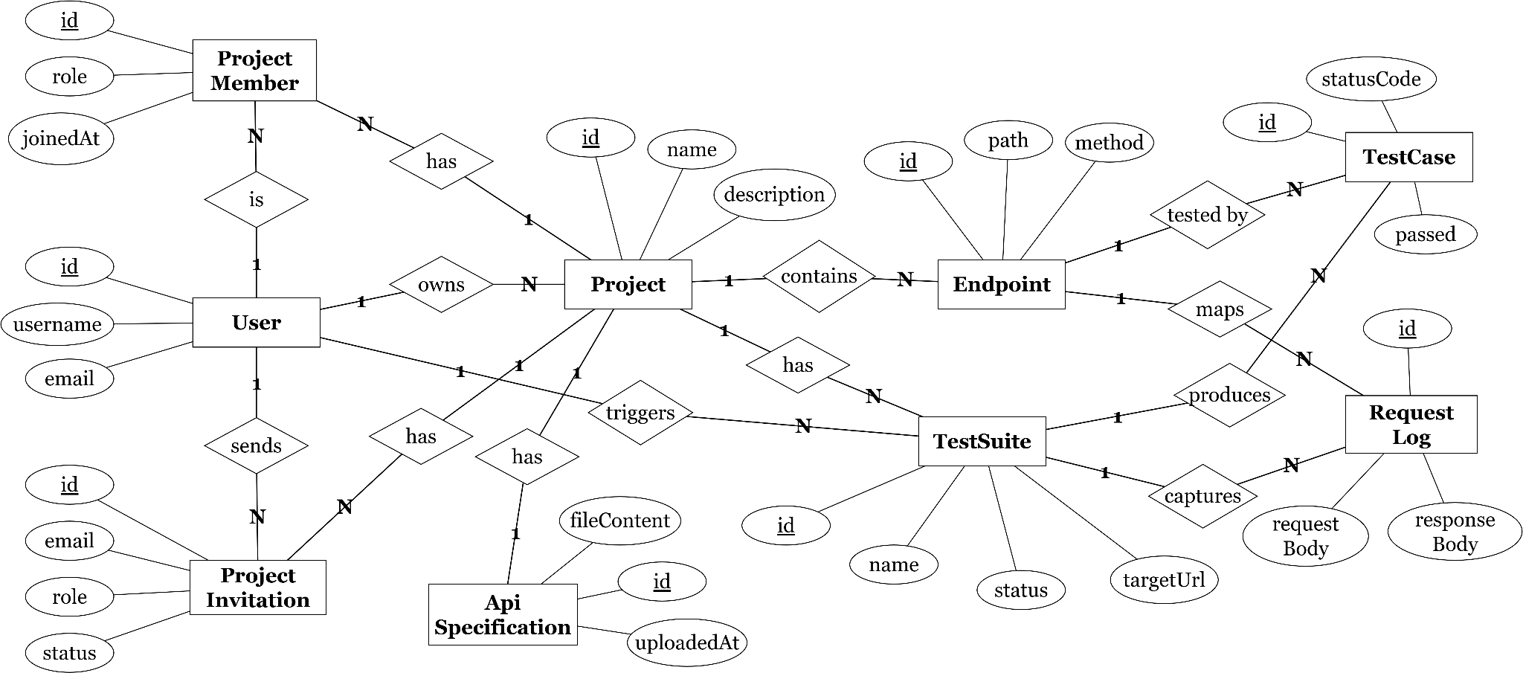
Figure 17: Entity Relationship Diagram

4.2 Database schema
PK = primary key, FK = foreign key, → = references. All identifiers are UUID strings.
Schema | Attribute | Type
User | id (PK) | TEXT (UUID)
User | username | TEXT, UNIQUE
User | email | TEXT, UNIQUE
User | password | TEXT (bcrypt hash)
User | createdAt | TIMESTAMP
User | updatedAt | TIMESTAMP
Project | id (PK) | TEXT (UUID)
Project | name | TEXT
Project | description | TEXT (nullable)
Project | ownerId (FK) | TEXT → User
Project | createdAt | TIMESTAMP
Project | updatedAt | TIMESTAMP
ProjectMember | id (PK) | TEXT (UUID)
ProjectMember | projectId (FK) | TEXT → Project
ProjectMember | userId (FK) | TEXT → User
ProjectMember | role | ENUM(admin, tester, viewer)
ProjectMember | joinedAt | TIMESTAMP
ProjectInvitation | id (PK) | TEXT (UUID)
ProjectInvitation | projectId (FK) | TEXT → Project
ProjectInvitation | email | TEXT
ProjectInvitation | role | ENUM(admin, tester, viewer)
ProjectInvitation | token | TEXT, UNIQUE
ProjectInvitation | status | ENUM(pending, accepted, declined, expired)
ProjectInvitation | invitedById (FK) | TEXT → User
ProjectInvitation | expiresAt | TIMESTAMP
ProjectInvitation | createdAt | TIMESTAMP
ApiSpecification | id (PK) | TEXT (UUID)
ApiSpecification | projectId (FK) | TEXT → Project, UNIQUE
ApiSpecification | fileName | TEXT
ApiSpecification | fileContent | TEXT (raw OpenAPI 3.0)
ApiSpecification | generatedByAI | BOOLEAN
ApiSpecification | uploadedAt | TIMESTAMP
Endpoint | id (PK) | TEXT (UUID)
Endpoint | projectId (FK) | TEXT → Project
Endpoint | path | TEXT
Endpoint | method | ENUM(GET, POST, PUT, PATCH, DELETE)
Endpoint | description | TEXT (nullable)
Endpoint | addedManually | BOOLEAN
Endpoint | createdAt | TIMESTAMP
TestSuite | id (PK) | TEXT (UUID)
TestSuite | projectId (FK) | TEXT → Project
TestSuite | name | TEXT (nullable)
TestSuite | status | ENUM(pending, running, completed, failed)
TestSuite | jobId | TEXT (nullable)
TestSuite | targetUrl | TEXT
TestSuite | timeBudget | INTEGER
TestSuite | mutationRate | DOUBLE PRECISION
TestSuite | totalEndpoints | INTEGER
TestSuite | coveredEndpoints | INTEGER
TestSuite | totalTestCases | INTEGER
TestSuite | passedTestCases | INTEGER
TestSuite | failedTestCases | INTEGER
TestSuite | triggeredById (FK) | TEXT → User
TestSuite | startedAt | TIMESTAMP (nullable)
TestSuite | completedAt | TIMESTAMP (nullable)
TestSuite | createdAt | TIMESTAMP
TestCase | id (PK) | TEXT (UUID)
TestCase | testSuiteId (FK) | TEXT → TestSuite
TestCase | endpointId (FK) | TEXT → Endpoint
TestCase | requestBody | JSONB (nullable)
TestCase | requestHeaders | JSONB (nullable)
TestCase | statusCode | INTEGER (nullable)
TestCase | responseBody | JSONB (nullable)
TestCase | responseTimeMs | INTEGER (nullable)
TestCase | passed | BOOLEAN
TestCase | failureExplanation | TEXT (nullable)
TestCase | createdAt | TIMESTAMP
RequestLog | id (PK) | TEXT (UUID)
RequestLog | testSuiteId (FK) | TEXT → TestSuite
RequestLog | endpointId (FK) | TEXT → Endpoint (nullable)
RequestLog | seq | INTEGER
RequestLog | method | TEXT
RequestLog | path | TEXT
RequestLog | url | TEXT
RequestLog | statusCode | INTEGER (nullable)
RequestLog | durationMs | INTEGER (nullable)
RequestLog | requestHeaders | JSONB (nullable)
RequestLog | requestBody | TEXT (nullable)
RequestLog | requestTruncated | BOOLEAN
RequestLog | responseHeaders | JSONB (nullable)
RequestLog | responseBody | TEXT (nullable)
RequestLog | responseTruncated | BOOLEAN
RequestLog | createdAt | TIMESTAMP
Table – 1: Database schema table

5. AI Engineering Design
AutoRestTest concentrates its intelligence in the testing engine, which transforms a static API description into an adaptive testing process. Rather than treating operation selection, dependency resolution, parameter selection, and value generation as isolated, one-off steps, the engine coordinates them as a single learning system that combines a semantic dependency graph, Large-Language-Model (LLM) value generation, and multi-agent reinforcement learning (MARL).

5.1 AI Pipeline
The AI pipeline turns the target service's OpenAPI description into concrete test requests and refines its own strategy from every server response. As shown in Figure 18, it operates in two phases: an initialization phase that prepares the search space, and an iterative testing-execution phase that explores it within a fixed time budget.
Initialization phase: The pipeline begins by parsing the target service's OpenAPI 3.0 specification, extracting every operation together with its parameters and request/response schemas. From these operations it constructs the Semantic Property Dependency Graph (SPDG) — a directed graph in which each node is an API operation and each edge represents a potential data dependency between two operations. Edges are weighted by the cosine similarity between the names of one operation's output properties and another's input properties, so that operations likely to feed one another (for example, a “create user” call that produces an identifier later consumed by a “get user” call) are linked with a high initial weight. This lets the tool prioritise plausible dependencies instead of blindly matching every input against every output. Finally, the reinforcement-learning agents are created, each with its own Q-table mapping the choices it can make to their expected reward. During this phase the Value Agent also pre-generates realistic, context-aware values by querying the LLM with few-shot prompts in JSON mode; because this step is not part of the time-bounded loop, it can be performed ahead of testing and cached.
Testing-execution phase: Testing then runs as an iterative loop driven by four cooperating agents, each responsible for a single decision:
Operation Agent — selects the next API operation to exercise.
Parameter Agent — chooses which combination of parameters to include.
Value Agent — generates a value for each parameter, choosing the most effective data source: an LLM-generated value, a value carried over from a dependent operation, or a type-based default.
Dependency Agent — supplies values drawn from previously successful operations, guided by the SPDG.
In the implementation, the Value Agent's responsibilities are further divided across dedicated value, data-source, and request-body agents, with an optional header agent for authenticated targets; the four roles above capture the core decision structure.
Request generation and mutation: On each iteration, the Request Generator assembles a concrete HTTP request from the chosen operation, parameters, values, and headers. A Mutator then perturbs roughly 20% of requests — altering values, types, headers, or methods — specifically to probe error handling and surface faults that valid requests would never reveal. The request is dispatched to the Service Under Test (SUT), and its response is captured and analysed: successful (2xx) responses yield values that are cached for reuse in later requests, while internal server errors (5xx) are recorded for the final report.
The learning loop: The response is the reward signal that closes the loop. Every agent's Q-table is updated using value-decomposition Q-learning with a temporal-difference update, which distributes a shared reward across the agents so that each converges toward its best action while accounting for the others' choices. Action selection follows an ε-greedy strategy in which the exploration rate decays over the run — from broad exploration early on to focused exploitation later — balancing the discovery of new behaviours against the reuse of proven ones. In parallel, the SPDG is refined: edge weights are increased for dependencies confirmed by successful responses, decreased for those that fail, and edges that fall below a threshold are pruned, so the dependency model grows more accurate as testing progresses. This cycle repeats until the configured time budget is exhausted, after which the pipeline emits the testing report summarising tested operations, code and operation coverage, the status-code distribution, detected 500-level server errors, and the full execution history.
Because each component addresses a different source of difficulty — the SPDG narrows the dependency search space, the LLM produces domain-realistic inputs, and MARL coordinates the testing strategy over time — they are complementary: the pipeline achieves broader coverage and detects more faults than approaches that optimise any one of these steps in isolation.
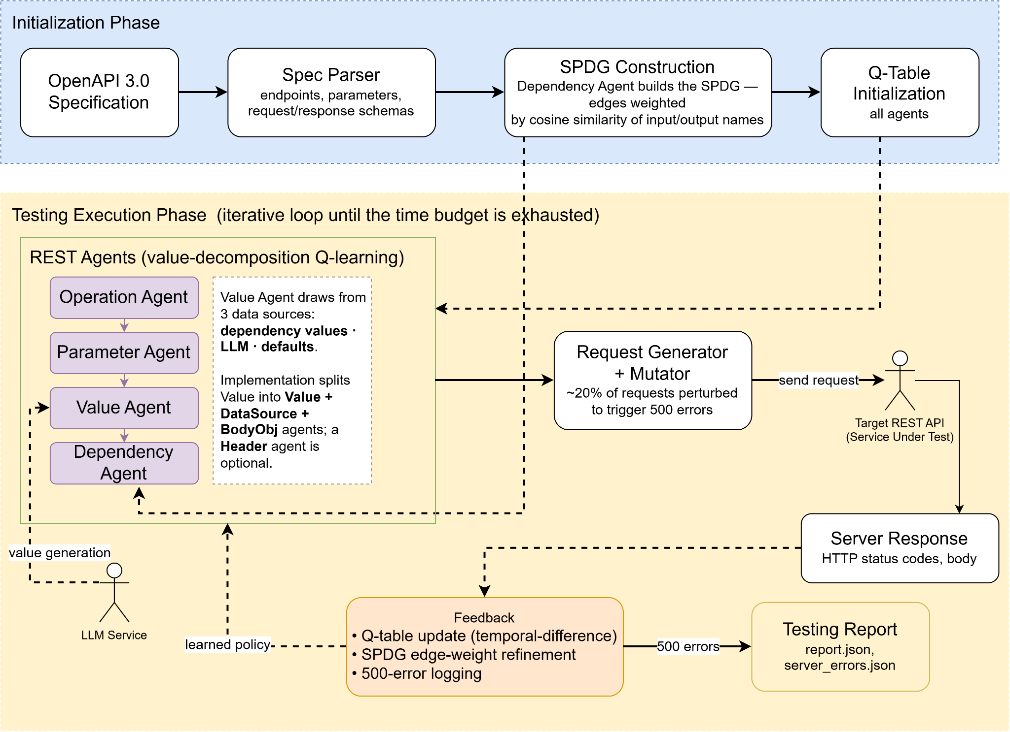
Figure 18: AI system workflow diagram

5.2 Model Selection
AutoRestTest does not depend on any single language model. Because the testing engine communicates with the LLM through a standard OpenAI-compatible REST API, the user is free to choose whichever model best suits their budget and accuracy needs, provided it meets three conditions: it is reachable through an OpenAI-compatible API, it supports structured JSON output (JSON mode), and it is capable of interpreting OpenAPI specifications to generate valid, context-aware request data. Suitable models include OpenAI's GPT family and open-weight models such as gpt-oss-20b (used by default via OpenRouter); other providers such as Google Gemini can also be used when accessed through an OpenAI-compatibility endpoint. The selected model is set in a single configuration entry, so switching models — for example, moving from a free open-weight model during development to a stronger frontier model for higher-fidelity value generation — requires only a configuration change and no modification to the engine.

5.3 Prompt Design
The engine relies on carefully engineered prompts to drive its LLM interactions. Rather than one general prompt, it uses a family of task-specific prompts that share a few common design principles: each injects the operation summary together with its OpenAPI schema, instructs the model to return a strict JSON structure (paired with the model's JSON mode), and supplies few-shot examples so the output matches the expected format. These prompts fall into four groups:
- Value-generation prompts: produce valid, context-aware values for an operation's parameters and request body.
- Feedback / retry prompts: regenerate values after a failed request by conditioning on the server's response, dropping inputs that caused the failure.
- Classification prompts: label failures (for example, parameter-constraint, format, or dependency errors) so the engine can respond appropriately.
- Utility prompts: handle supporting tasks such as repairing malformed JSON and identifying authentication parameters.
Here is some example:
CLASSIFICATION_PROMPT = ''' Given an error message, classify the error as one of "PARAMETER CONSTRAINT, FORMAT, PARAMETER DEPENDENCY, OPERATION DEPENDENCY". '''
REQUEST_BODY_GEN_PROMPT = """ Given a summary of an operation its request body schema from its OpenAPI Specification, generate a valid context-aware request body for the operation. Return the answer as a JSON object with the following structure: { "request_body": [correct request body] } In the case where the request body is an object, return a correctly formatted object as the [correct request body] value. In the object, include all required fields as specified from the OpenAPI Specification for object request bodies, but otherwise include/exclude optional properties to ensure the object is accepted. In the case where the request body is an array, use a list as the request_body value. Do not solely rely on the given constraint values, and ensure you read the associated descriptions for maximum accuracy. Use any provided example values to guide your generation formatting."""
IDENTIFY_AUTHENTICATION_SYSTEM_MESSAGE = "You will receive a summary of an operation and its full schema from the OpenAPI Specification. Your goal is to determine if the operation consists of any authentication information sent as parameters in either the query or the request body. When referring to request body parameters, identify object properties that might be used for authentication. Authentication information specifically refers to either usernames or passwords (or similar). Return your result in the specified JSON format."

6. User Manual & User Interface

6.1 Introduction
AutoRestTest is a web-based, AI-powered, collaborative platform for automated REST API testing. It brings together several capabilities that are normally spread across separate tools into a single project workspace:
- API specification management: Upload an existing OAS (OpenAPI Specification) document in .json or .yaml format, or generate one automatically by uploading a zip of the API's source code.
- Dependency visualization: a semantic dependency graph shows which API operations rely on data produced by other operations, before a single request is ever sent.
- AI-driven test execution: a multi-agent reinforcement-learning and LLM-backed engine generates and runs a test suite against a live target API, with real-time status and a detailed report.
- Team collaboration: invite teammates to a project with a specific role (Admin, Tester, or Viewer) and work together on the same specification, endpoints, and test runs.
This manual walks through every page and feature of the application, in the order a new user would typically encounter them, so that any user regardless of technical background can get started quickly.

6.2 System Requirements
- A modern web browser (Google Chrome, Firefox, Microsoft Edge, or Safari).
- An internet connection.
- An AutoRestTest account (registered through the application itself).
- For AI powered API specification generation from source code: the source code packaged as a single .zip archive, up to 50 MB.
No installation is required on the user's computer. The entire platform runs in the browser.

6.3 Accessing AutoRestTest
Open your browser and navigate to the AutoRestTest URL provided to you. If you are not already signed in, the application takes you to the Landing page.
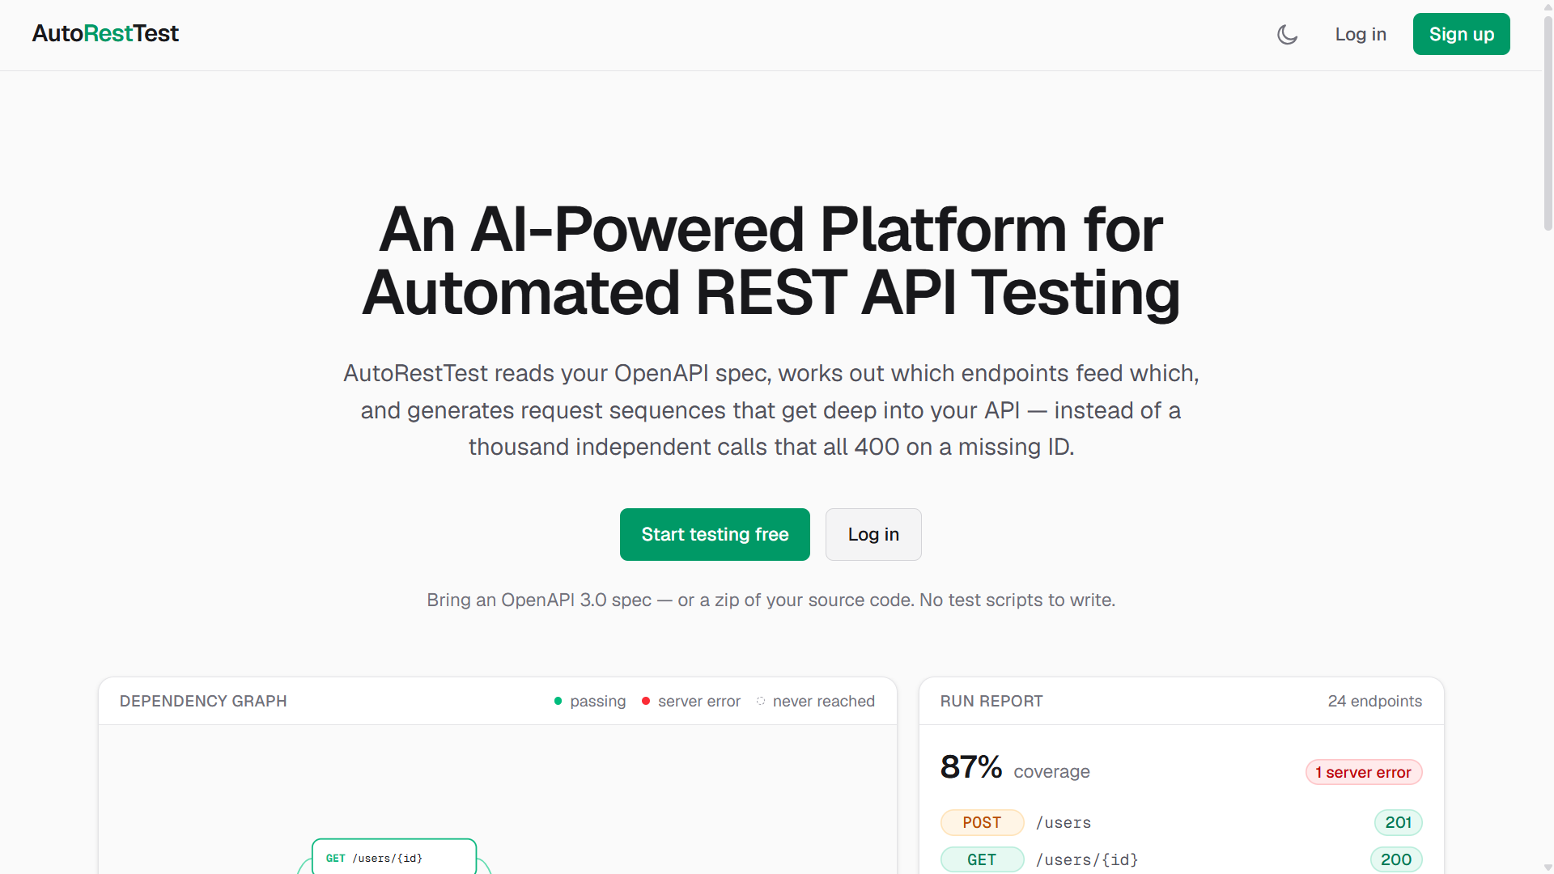
Figure 19: AutoRestTest Landing Page

6.4 Creating an Account
6.4.1 Registering
If you do not already have an account, you can create one from the Register page.
1. On the Landing page, click "Sign Up" on the right side of the top navigation row.
2. Fill in the registration form:
- Username: a unique name, 3–32 characters. This becomes your permanent sign-in name and cannot be changed later.
- Email: a valid email address you have access to. This also becomes your permanent email address.
- Password: at least 8 characters.
3. Click "Create account".
Registration does not create your account immediately, it only reserves it. AutoRestTest sends a six-digit verification code to the email address you entered, and you are taken to the Confirm Your Email screen.
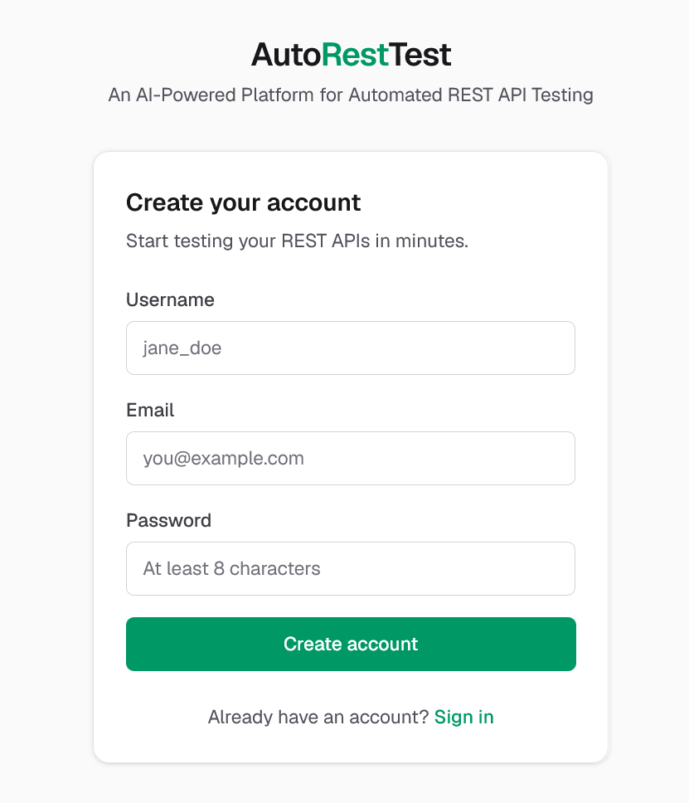
Figure 20: Account register page
6.4.2 Verifying Your Email
The Confirm Your Email screen shows six input boxes for the six-digit code that was emailed to you. Typing (or pasting) the code fills the boxes automatically and, once all six digits are entered, the form submits itself, there is no separate button to click. Your account is only created at this step, once the code is verified.
- If you did not receive the code, use the "Resend the code" link. Once used, it is disabled for 60 seconds before it can be used again.
- If you entered the wrong email address, use the "Sign up again" link to restart registration.
On success you are signed in automatically and taken straight to your Projects page. There is no separate account-approval step and no unverified state to wait out.
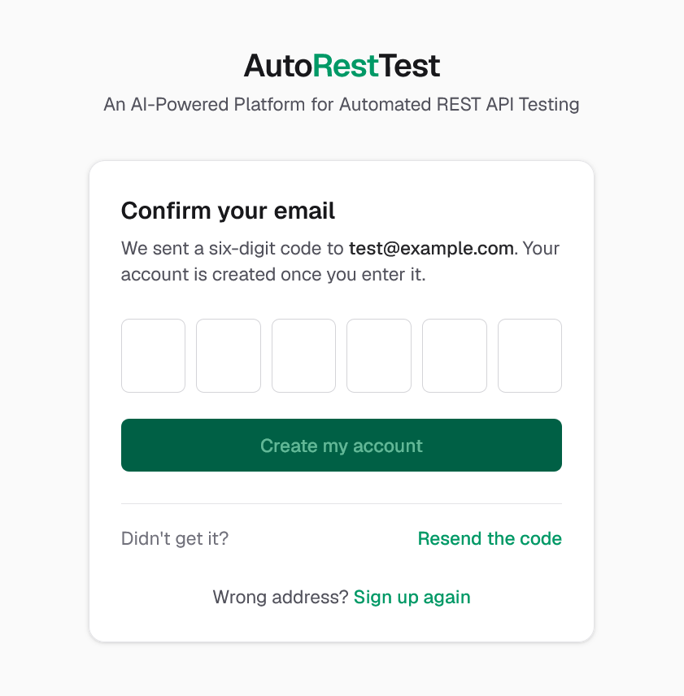
Figure 21: Email verification page

6.5 Logging In
- On the Login page, enter your Email or username and your Password in a single combined field for the identifier. Either your email address or your username is accepted.
- Click "Sign in".
- If your credentials are correct, you are taken directly into the application, on your Projects page.
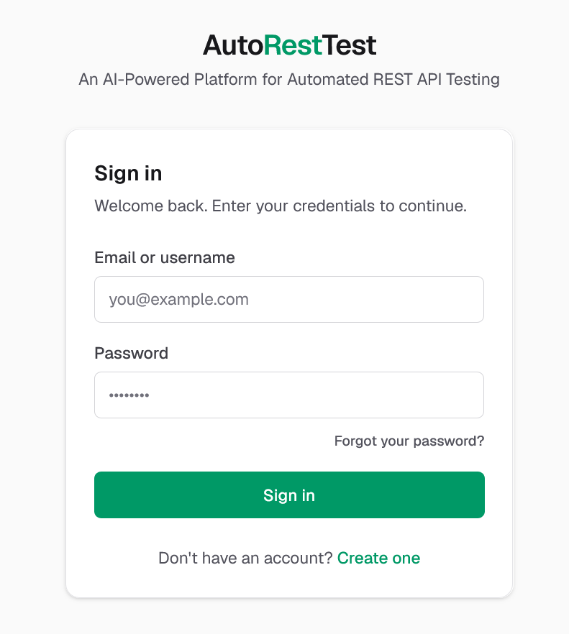
Figure 22: Login page
6.5.1 Forgot Password
If you have forgotten your password, click "Forgot your password?" on the Login page.
- Enter the email address on your account and click "Send reset link".
- Check your inbox for a reset link. For security, the screen shows the same confirmation message whether or not the address is registered, so it cannot be used to discover which emails have an account.
- The link works once and expires after 30 minutes.
- Opening the link takes you to the Choose a New Password screen, where you enter and confirm a new password (at least 8 characters, and the two entries must match).
Resetting your password signs you out of every device and browser you were previously signed in on, including the one you are using now. Sign in again with your new password.

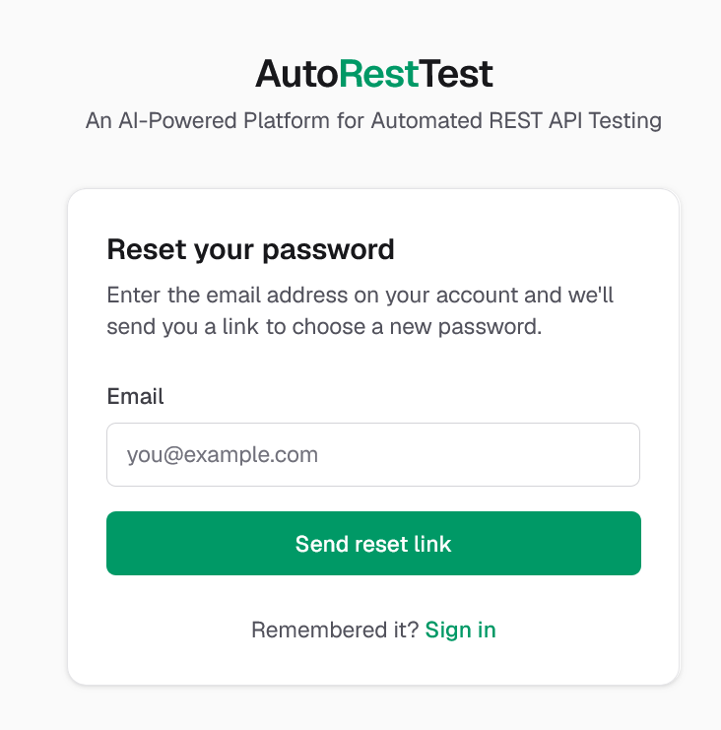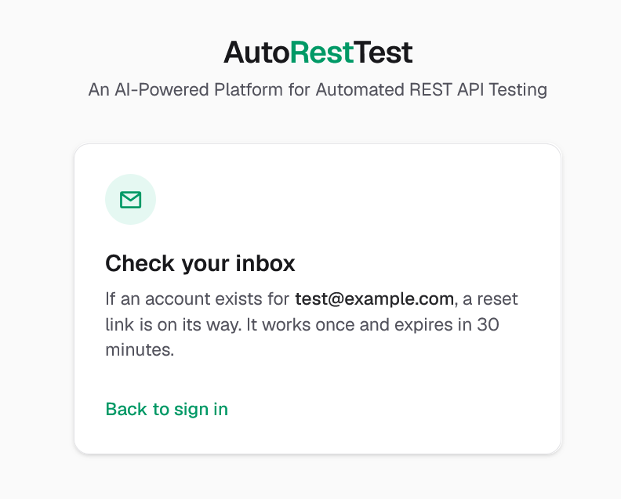
Figure 23: Reset password page

6.6 The Application Layout
After signing in, the application uses a single top bar for all navigation — there is no sidebar. From left to right, the top bar contains:
- AutoRestTest logo, which always returns to your Projects list.
- Project switcher, visible whenever you are inside a project; shows the current project's name and lets you jump directly to any other project without returning to the list first.
- Invitations bell icon, shown only when you have at least one pending project invitation, with a badge showing how many.
- Your display name, and a light/dark theme toggle.
- Account menu, opened from your avatar, with links to "Invitations", "Settings", and "Sign out".
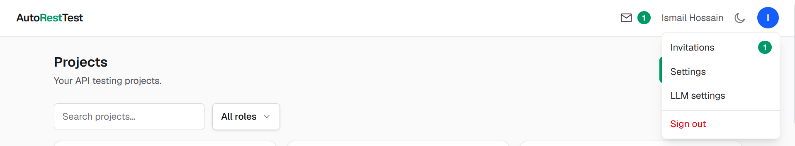
Figure 24: Navbar

6.7 Projects
The Projects page is what you see immediately after signing in. It is the application's home page. Each project is an independent workspace holding one API specification, its endpoints, its dependency graph, its test runs, and its team.
6.7.1 Viewing Your Projects
The Projects page offers:
- A search box, which filters by project name or description.
- A role filter, with options All roles, Owner, Admin, Tester, and Viewer.
- A view toggle, switching between a Table view and a Cards view; your choice is remembered for next time.
The table view's columns such as Name, Members, Role, and Last activity can each be clicked to sort the list; clicking the same column again reverses the sort order. A Status column shows badges for the project's specification state (No spec / Spec uploaded / Spec generated), any AI generation in progress (Generating… / Awaiting review / Generation failed), and the status of its most recent test run.
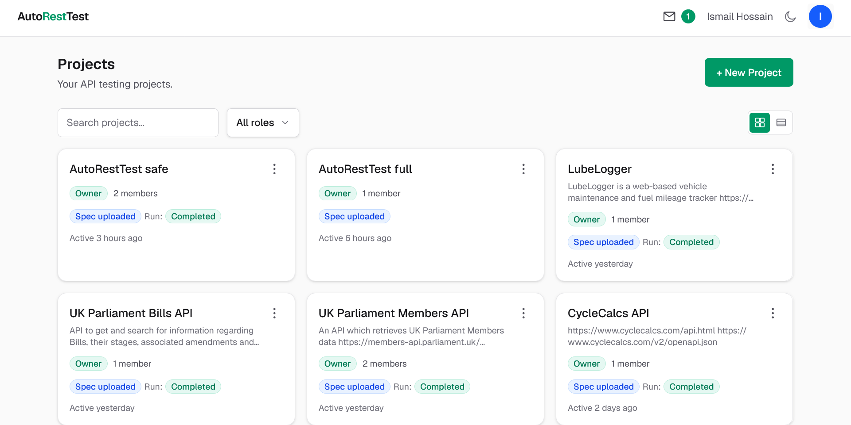
Figure 25: Homepage dashboard page
6.7.2 Creating a Project
1. Click "+ New Project".
2. Enter a Name (required) and, optionally, a Description.
3. Click "Create project".
You are taken directly into the new project, on its Overview tab.
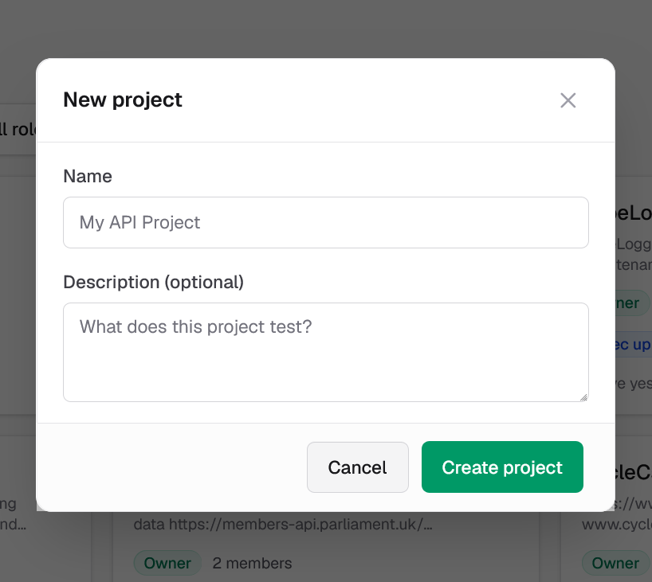
Figure 26: Create new project form
6.7.3 Editing or Deleting a Project
Only a project's owner can edit or delete it. From the project's own page, use the Edit and Delete buttons next to the project name; from the Projects list, open the row menu on a project you own. Deleting a project asks for confirmation and permanently removes the project and everything in it such as its specification, endpoints, dependency graph, test runs, and captured requests.

6.8 Project Roles and Permissions
Every project has one owner and any number of members, each holding one of three roles. Permissions are enforced both in the interface and on the server.
Role | Can do
Owner | Everything below, plus rename or delete the project itself, and manage all members.
Admin | Manage the API specification and endpoints; configure, run, and manage test suites; manage team members and invitations.
Tester | Configure and trigger test runs; run individual captured or live requests. Cannot change the specification, endpoints, or team.
Viewer | Read-only access to everything in the project; cannot change or run anything.

6.9 Project Overview Tab
Opening a project lands on its Overview tab. A tab row beneath the project name shows Overview, API Spec, Endpoints, Dependencies, Test Suites, Team; switches between the project's sections; it stays visible throughout.
The Overview tab shows the project's description, its owner, member count, creation date, and last-updated date, alongside a short list of its team (owner and members, each with a role badge).
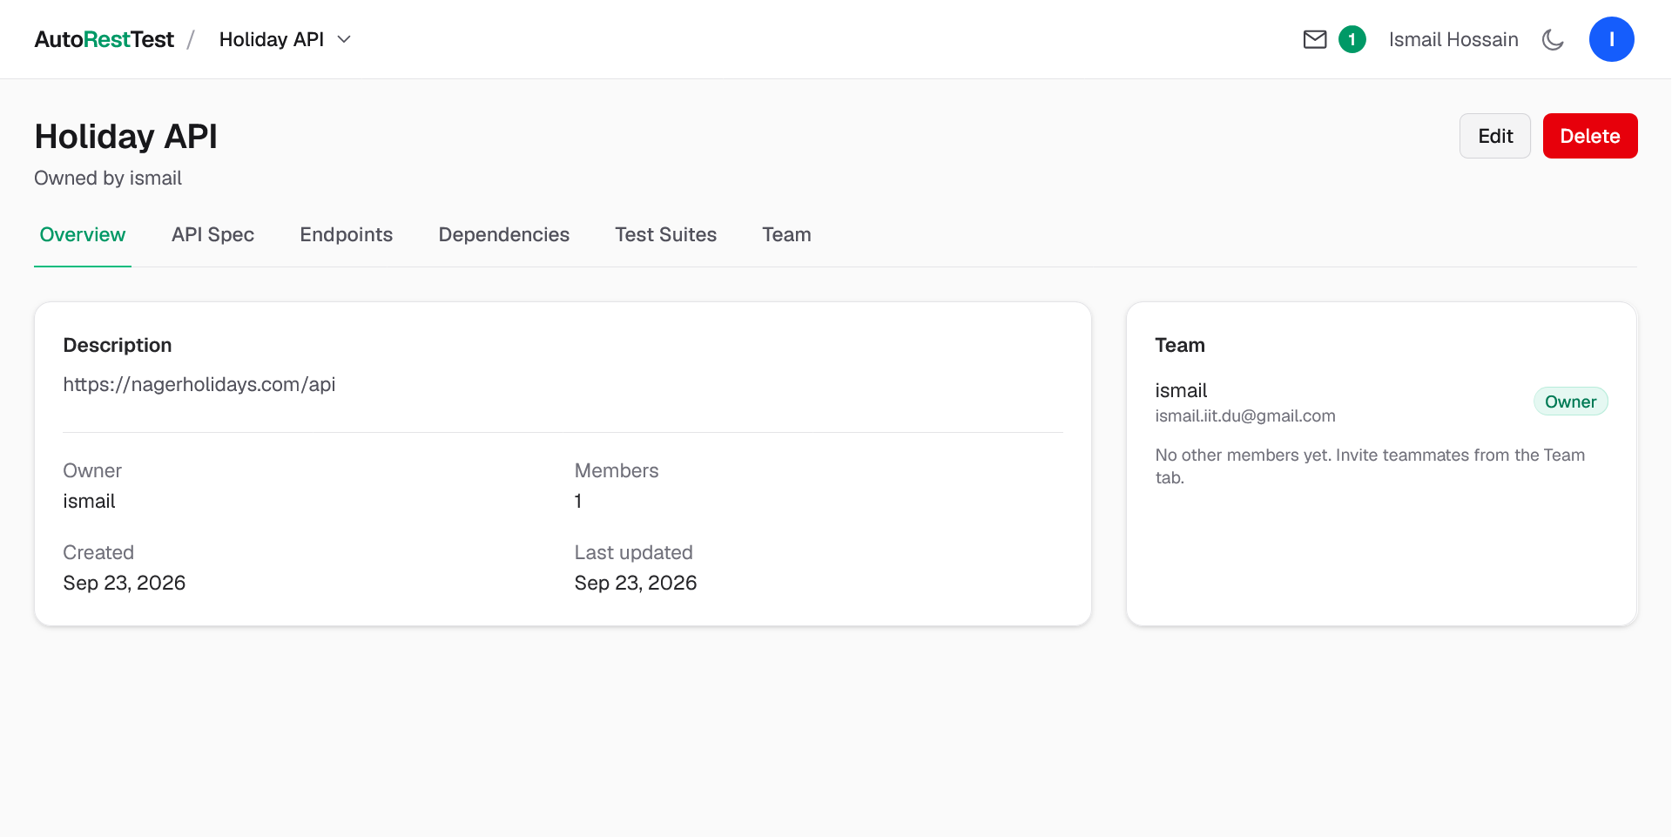
Figure 27: Project overview

6.10 API Specification
The API Spec tab is where a project's OpenAPI document lives. Project owners and admins are offered two ways to provide one, selected with a toggle at the top of the page: Upload OAS file, or Generate from source code. Testers and viewers see only the specification that is currently in place.
6.10.1 Uploading an OpenAPI File
1. Select "Upload OAS file".
2. Drag an OpenAPI document onto the drop zone, or click it to browse for a file. Accepted formats are .json, .yaml, and .yml, describing an OpenAPI 3.x document.
Endpoints are extracted automatically as soon as the file is accepted. If the project already has a specification, uploading a new one asks for confirmation first, since replacing it re-extracts the endpoint list and removes any endpoints that were added manually.
Once a specification is in place, its card shows the document's title, its OpenAPI version, an AI-generated badge if it came from the code-generation flow described below, its endpoint count, and its upload date along with Replace and Delete buttons. The raw specification text is shown below, with buttons to copy it or download it as a file.
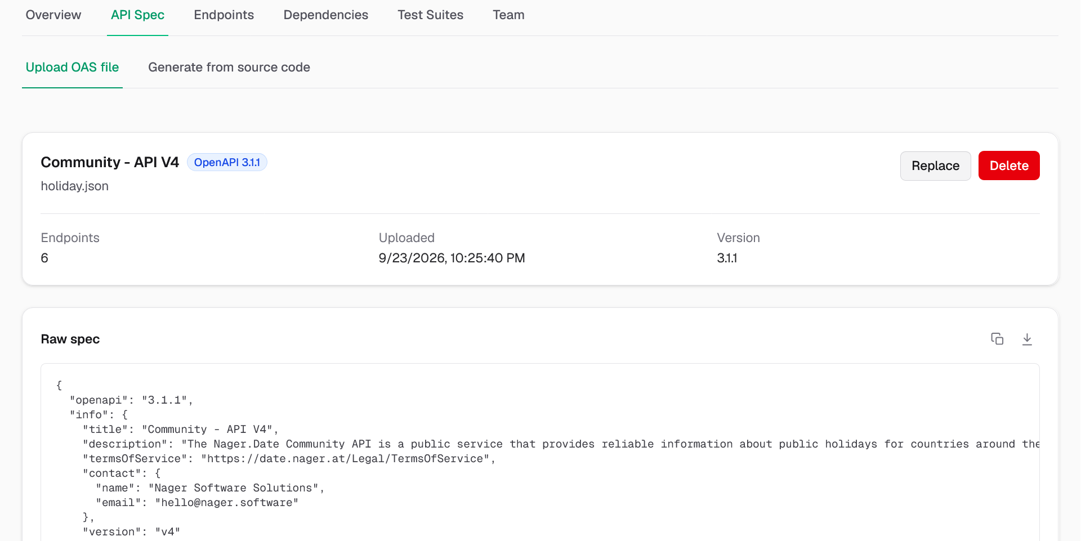
Figure 28: API Specification management
6.10.2 Generating a Specification from Source Code
If a project does not yet have an OpenAPI specification, AutoRestTest can generate one automatically by reading the API's own source code with an AI pipeline.
- Select "Generate from source code".
- Fill in the API title and Version (both prefilled from the project's own name and "1.0.0"), and, optionally, adjust Exclude directories by a comma-separated list of folders to skip (vendored dependencies and build output are pre-filled, since excluding them makes the analysis considerably faster and cheaper).
- Drag the project's source code onto the drop zone as a single .zip archive (up to 50 MB), or click to browse for one.
Generation runs in the background and can take a long time for a large codebase. The page shows a progress bar, the current step, and an elapsed-time counter, and updates automatically, so it is safe to leave the page and come back later. A "Cancel" button discards a generation that is still running.
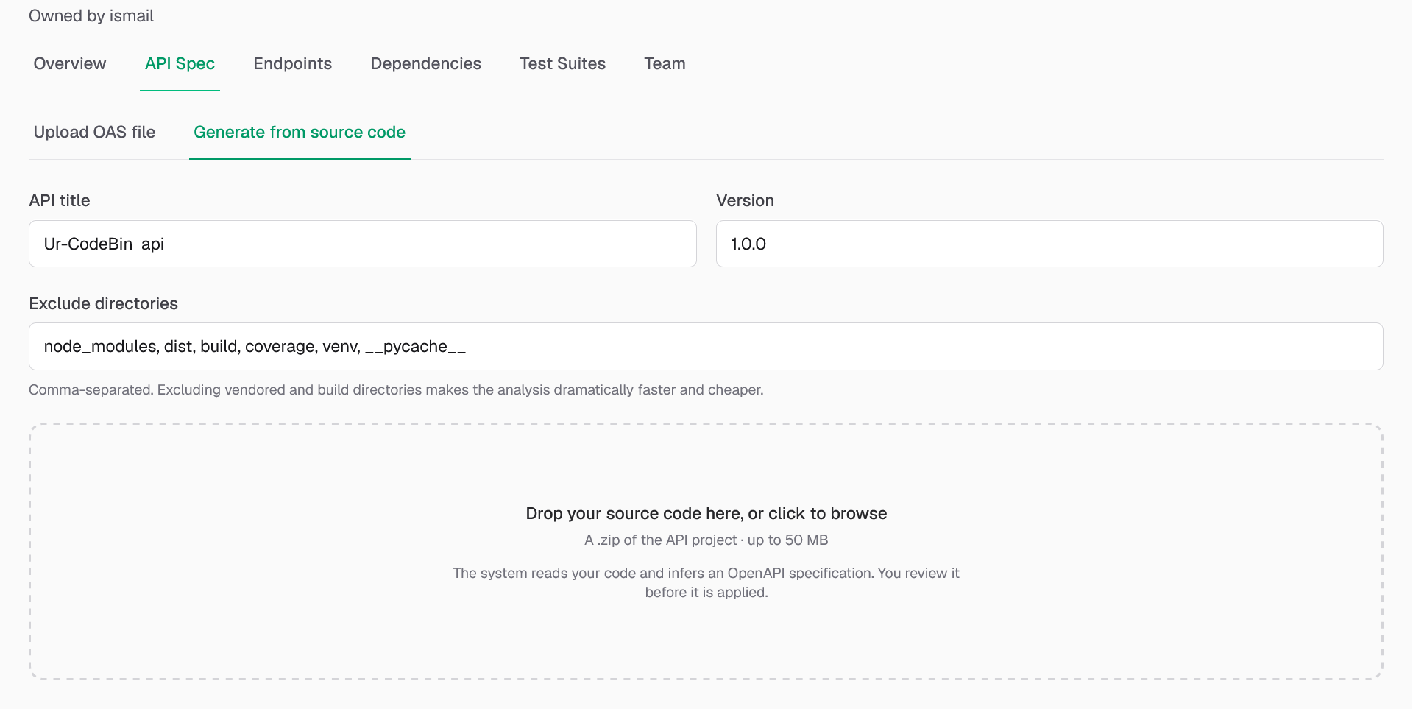
Figure 29: Auto generate API Specification
Once generation finishes, the specification is shown for review before it changes anything in the project. Any warnings from the pipeline; for example, a note that a required tool was unavailable and a lower-fidelity conversion was used are shown alongside it. Clicking "Review generated spec" expands the full generated document. From here you can either "Discard" the result, or click "Use this specification" to apply it as the project's specification (if one already existed, this asks for confirmation first, for the same reason as replacing an uploaded file).

6.11 Endpoints
The Endpoints tab lists every operation extracted from the project's specification, plus any added manually. A search box filters by path, method, or description.
Each row shows:
- An HTTP method badge (GET, POST, PUT, PATCH, DELETE, …).
- The endpoint's path, with inline indicators for whether authentication is required, how many parameters it takes, and whether it accepts a request body.
- Its description.
- A Source badge "From spec" for endpoints extracted from the uploaded or generated specification, or "Manual" for ones added by hand.
Clicking a row expands its full detail directly beneath it: authentication requirements, every parameter (with where it is sent, path, query, header, or cookie, its type, and whether it is required), the request body schema with an example payload, and the documented responses.
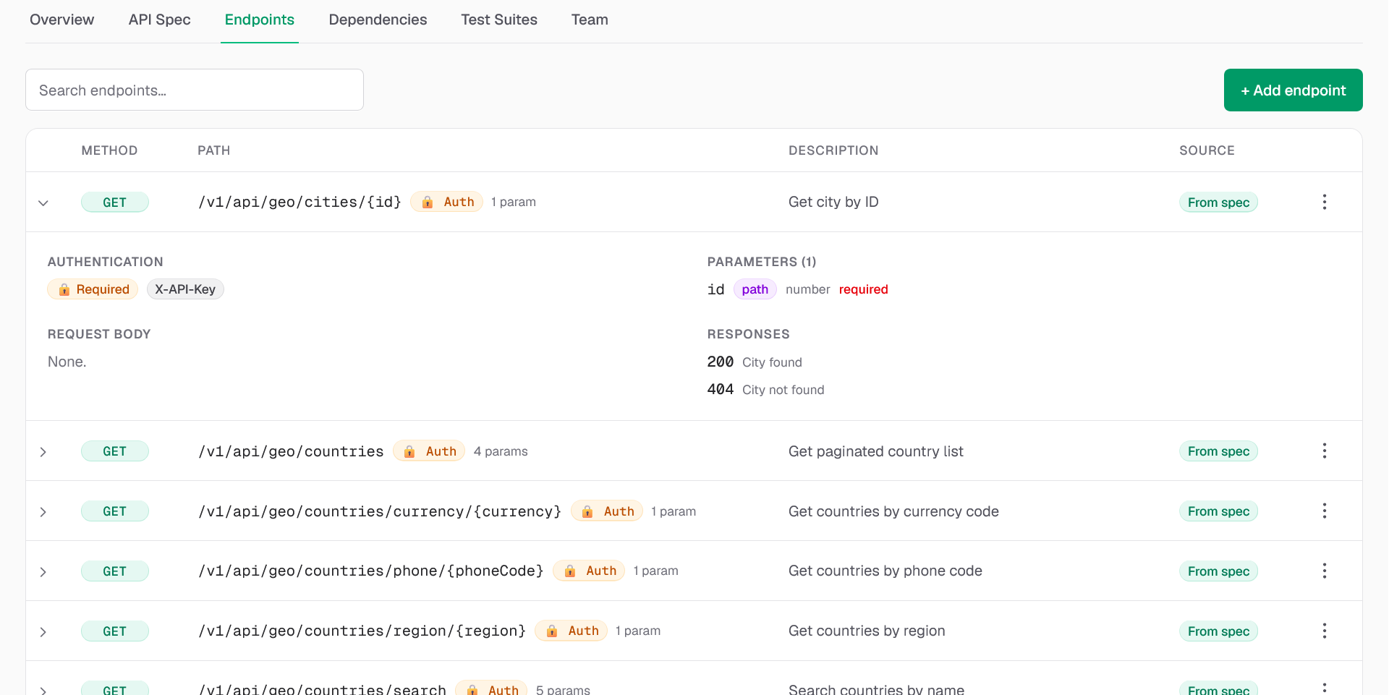
Figure 30: API Endpoints
Project owners and admins can add an endpoint manually with "+ Add endpoint"; choosing a Method, entering a Path, and optionally a Description for cases the specification does not cover. Manual endpoints can also be deleted from the row menu.
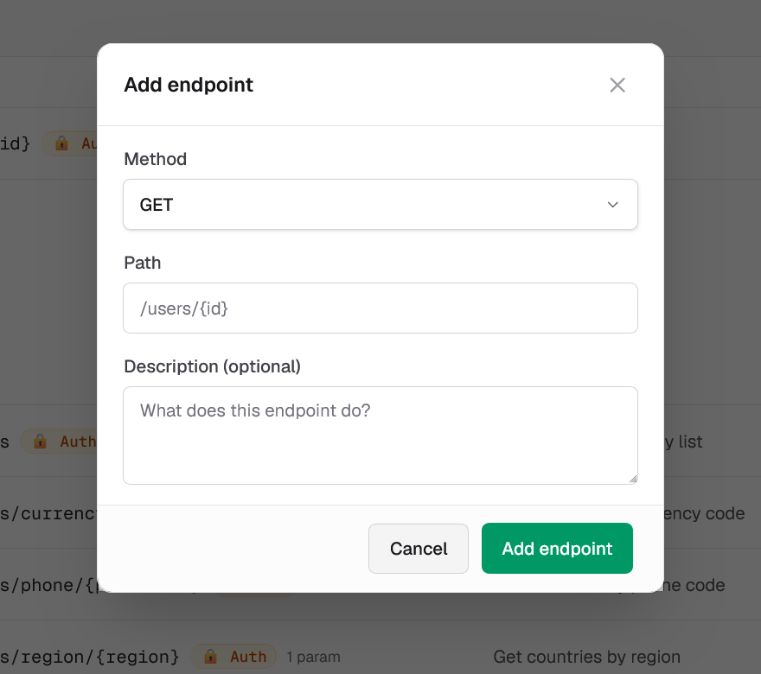
Figure 31: Add API Endpoint manually

6.12 Dependency Graph
The Dependencies tab visualizes the Semantic Property Dependency Graph the engine builds from the specification: an edge from one operation to another means the first operation is believed to produce a value the second one needs; for example, an edge from "create a resource" to "fetch that resource by id" because the id one returns is what the other expects as input. Building the graph only reads the specification; it never sends any request to the API itself.
- Click "Build dependency graph" (available to admins and testers; viewers ask a teammate with one of those roles to do it). This takes roughly a minute, since the engine compares every operation against every other one.
- Once built, the graph can be rebuilt at any time from the same tab.
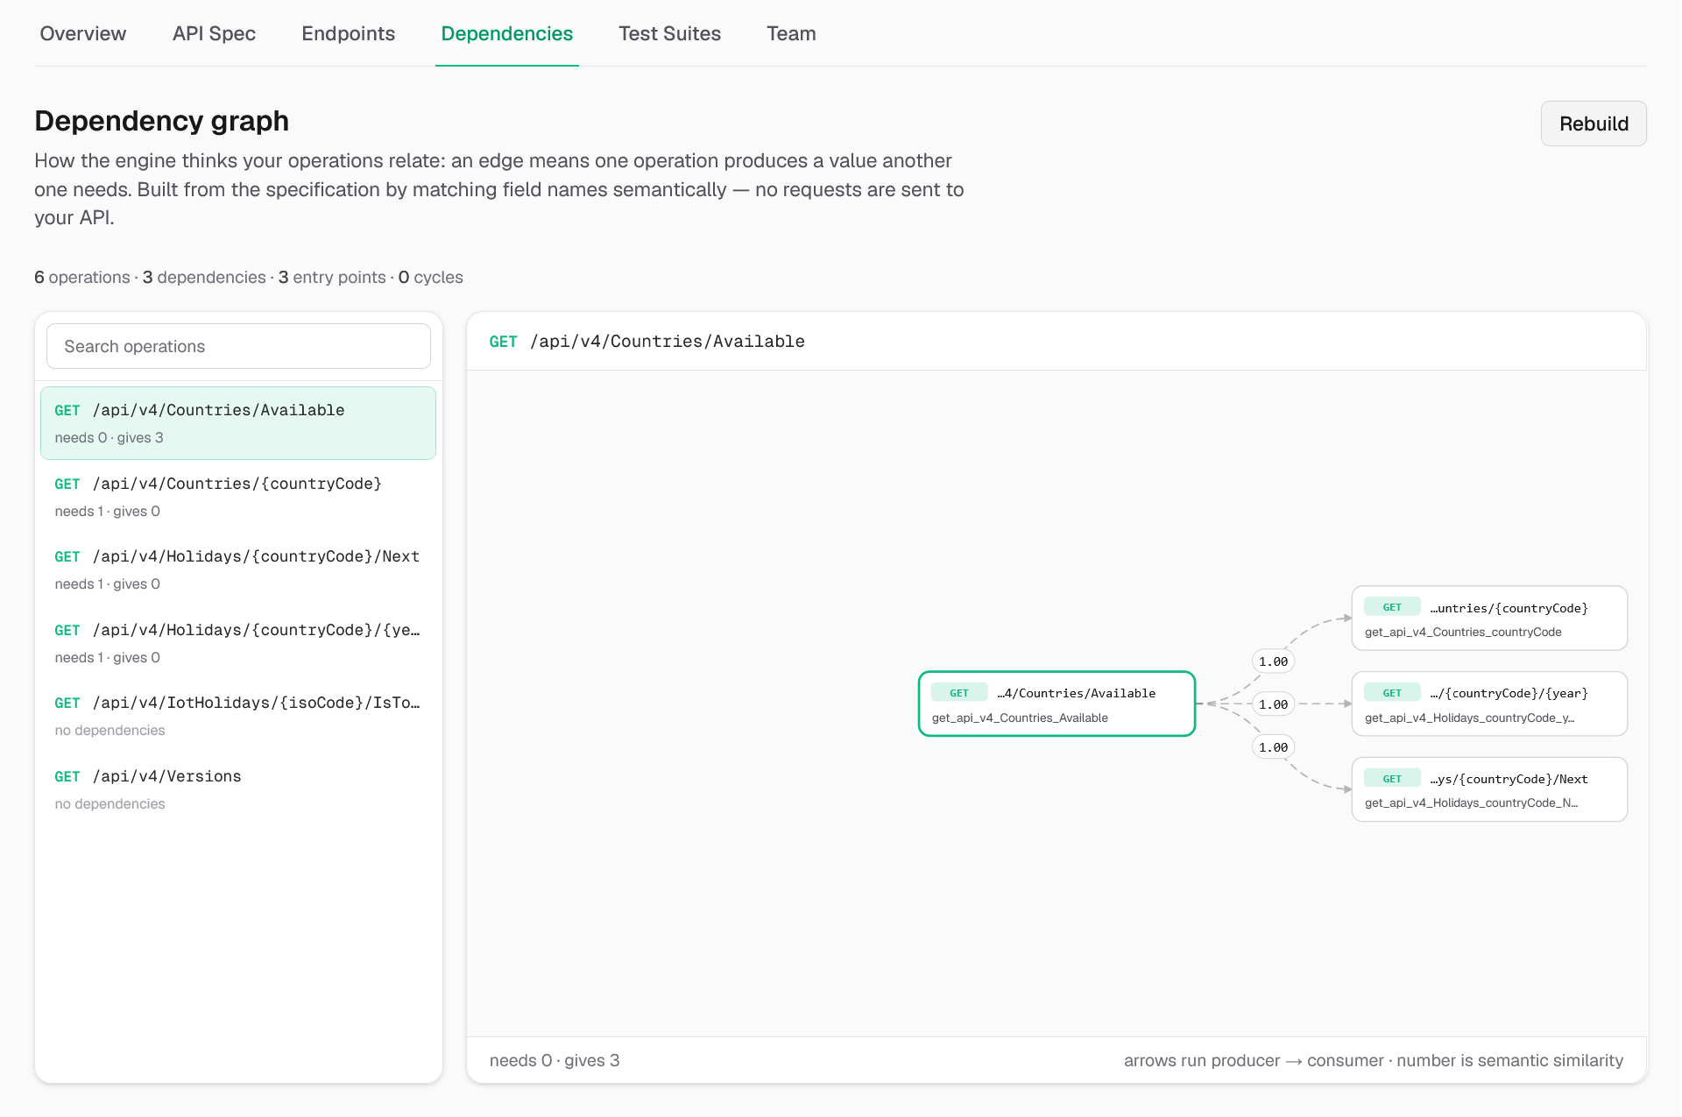
Figure 32: SPDG Visualization

6.13 Test Suites
The Test Suites tab is where AI-generated test runs are configured, executed, and reviewed. Each entry in its table is one run: its name (or a short generated id), status, target URL, pass/total result once complete, and creation date.
6.13.1 Creating a New Run
- Click "+ New run".
- Optionally give the run a Name.
- Enter the Target URL; the live base URL the engine will send requests to.
- Set the Time budget in seconds (default 300); how long the AI engine is allowed to spend generating and sending requests.
- Optionally set a Mutation rate between 0 and 1, controlling how aggressively the engine varies generated values.
- An "Advanced: Custom headers" section can be expanded to attach up to 20 HTTP headers to every request the run sends; for example an Authorization header for Basic or Bearer authentication, or an API-key header the target API expects. Each row is a free-form key and value; common header names are suggested as you type.
- Click "Create" to save the run.
A newly created run starts in the Pending state and has not sent any requests yet.
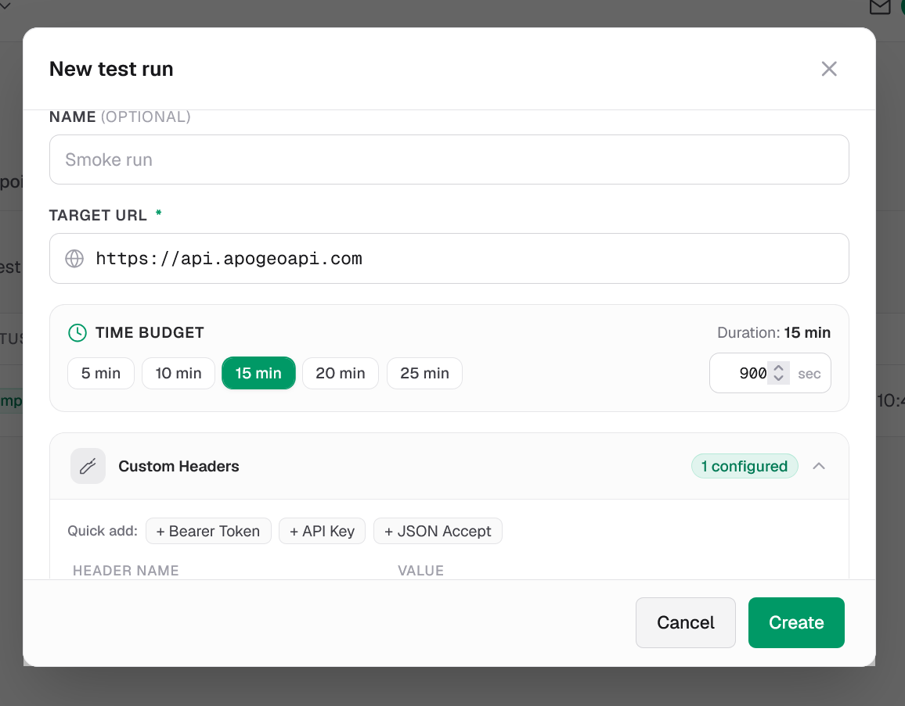
Figure 32: Create test suite
6.13.2 Running and Monitoring a Test Run
Open a pending run and click "Run tests" to start it. While running, the page polls automatically every few seconds and needs no manual refresh. A run can end in one of four states:
Status | Meaning
Pending | Configured, but not yet started.
Running | The AI engine is actively generating and sending requests to the target.
Completed | The run finished and produced a report.
Failed | The run could not be completed. For example because the target URL was unreachable or the engine service was unavailable. It can be retried.
6.13.3 Viewing the Test Report
Once a run completes, its page shows a full report. A run's job is finding real defects, not just checking for a non-2xx response: a request that receives a 4xx means the API correctly rejected a bad request, while a 5xx server error is the genuine fault signal. The headline banner reflects this directly, reporting the number of faults (5xx responses) detected, or confirming that none were found.
Below the banner:
- A KPI row shows coverage percentage, endpoints covered, total requests sent, and the breakdown of successful (2xx), client-error (4xx), and server-error (5xx) responses.
- A status-code distribution chart shows the same breakdown visually.
- A per-endpoint results table lists every endpoint the run exercised, with a Result badge (Successful / Client error / Server error), the exact status codes returned, and any failure explanation generated for it. It can be filtered by search term, outcome, or exact status code.
- For a completed run whose report has failures, an "Explain failures" button asks the AI engine to generate a plain-language explanation of what likely caused each failure and which request triggered it.
- The same dependency graph described in section 1.12 is shown again here, scoped to this run — which lets you see exactly which dependencies the reinforcement-learning agent confirmed while generating this particular run's requests.
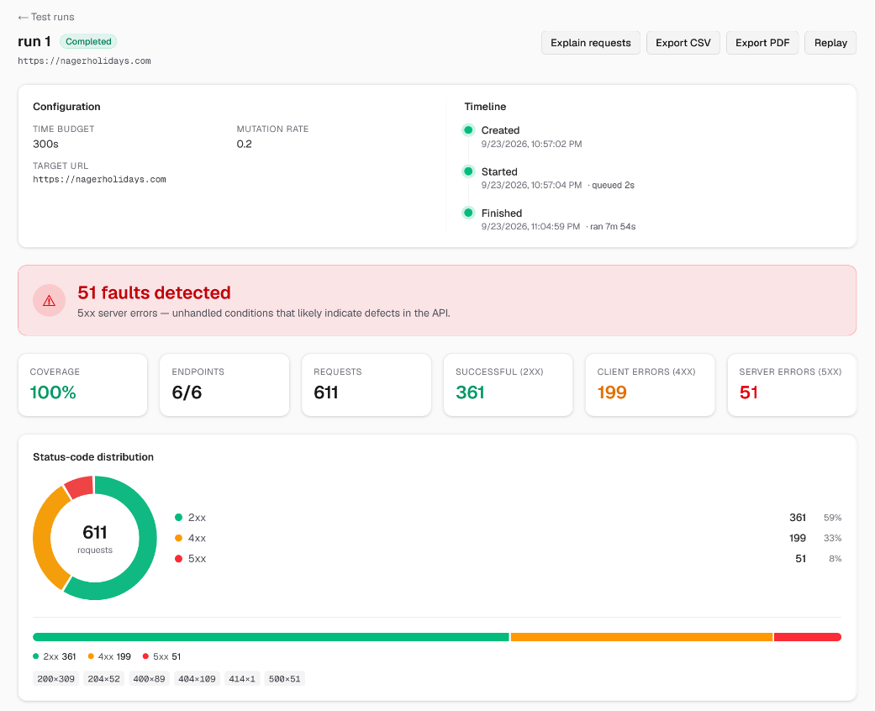
Figure 32: Test report
6.13.4 Exporting Reports
A completed run offers "Export CSV" and "Export PDF" buttons, each of which downloads the run's report in that format for sharing outside the application.
6.13.5 Replaying a Run
A completed run can be replayed with the "Replay" button: this resends that run's exact captured requests, in the same order, as a new, separate run — with no new AI generation involved. This is useful for confirming whether a fix actually resolved a previously-detected fault, since it is an apples-to-apples comparison against the same requests. A run's page shows a Run History panel listing its original run and every replay of it, so results can be compared side by side.

6.14 Captured Requests and Live Request Runs
From a completed run's report, clicking "View all captured requests" — or "View" next to a specific endpoint, or a node in the run's dependency graph — opens the full list of every request the engine actually sent during that run. The list can be filtered by endpoint and by response status class (2xx/3xx/4xx/5xx) or an exact status code, and is paginated 50 rows at a time.
Expanding a request shows the complete exchange: the request's method, URL, headers, and body on one side, and the response's status, duration, headers, and body on the other. A "Copy as curl" button builds a ready-to-run curl command from the captured request.
A "Run" button lets an admin or tester resend that exact request to the target API right now, and shows the fresh response inline as a Live response, without leaving the page. Because a non-GET/HEAD request can have real side effects on the target system, running anything other than a GET or HEAD request asks for confirmation first.
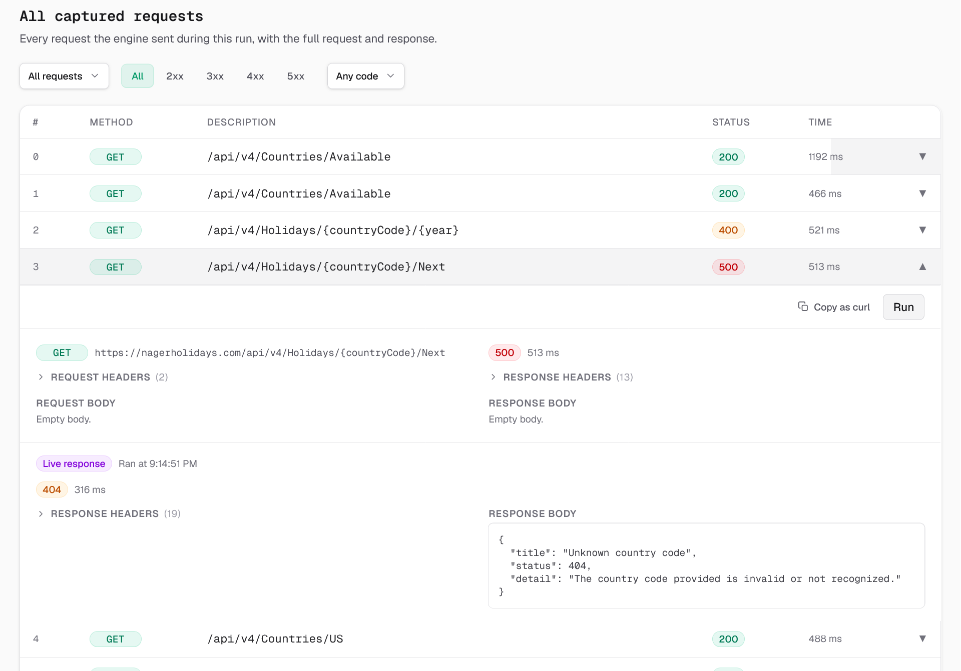
Figure 33: Test request log detail

6.15 Team and Collaboration
6.15.1 Managing Members
The Team tab (and the shorter team list on the Overview tab) shows everyone with access to the project: the owner, then every other member with their role. Owners and admins can change another member's role (Admin, Tester, or Viewer) directly from a dropdown next to their name, or remove them from the project with "Remove". Any member can leave a project they no longer need access to with "Leave".
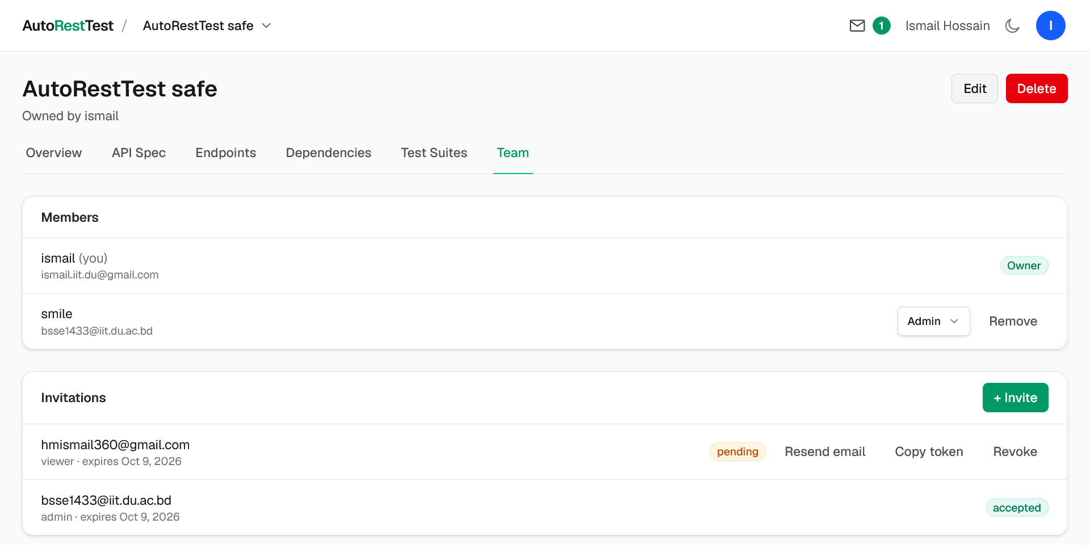
Figure 33: Team collaboration management
6.15.2 Inviting Team Members
1. On the Team tab, click "+ Invite" (owners and admins only).
2. Enter the teammate's Email address and choose a Role — Admin, Tester, or Viewer, each with a short description of what it allows.
3. Click "Send invite".
The invitation is emailed to that address. Pending invitations are listed on the Team tab with their role, expiry date, and status; each can be resent, have its invite token copied, or be revoked before it is accepted.
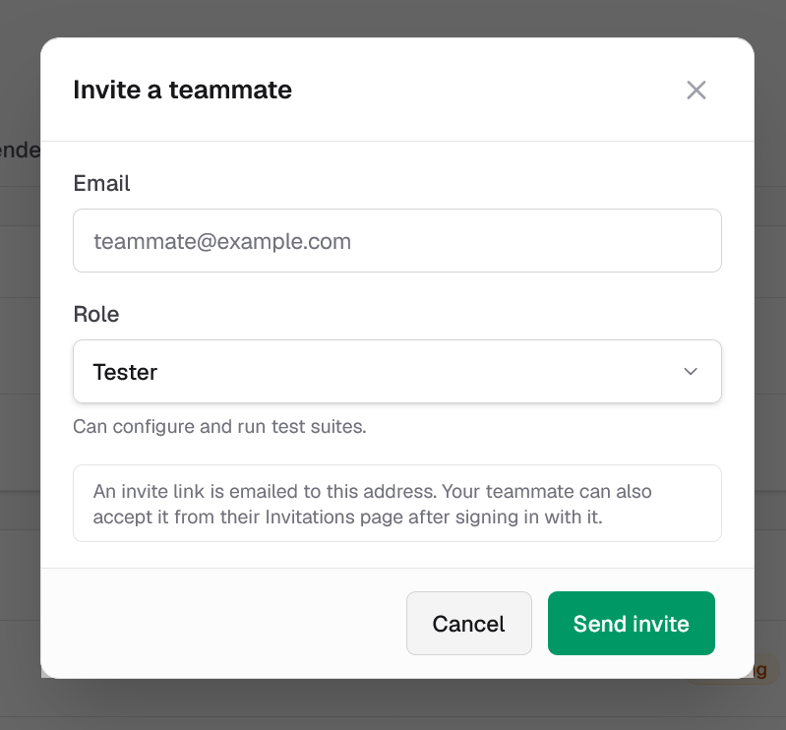
Figure 34: Add team member
6.15.3 My Invitations
Invitations addressed to the signed-in user's own account — from any project — are collected on the "Invitations" page, reached from the bell icon or account menu in the top bar. Each shows the project, the offered role, who sent it, and when it expires, with Accept and Decline buttons. Accepting takes you directly into the project.
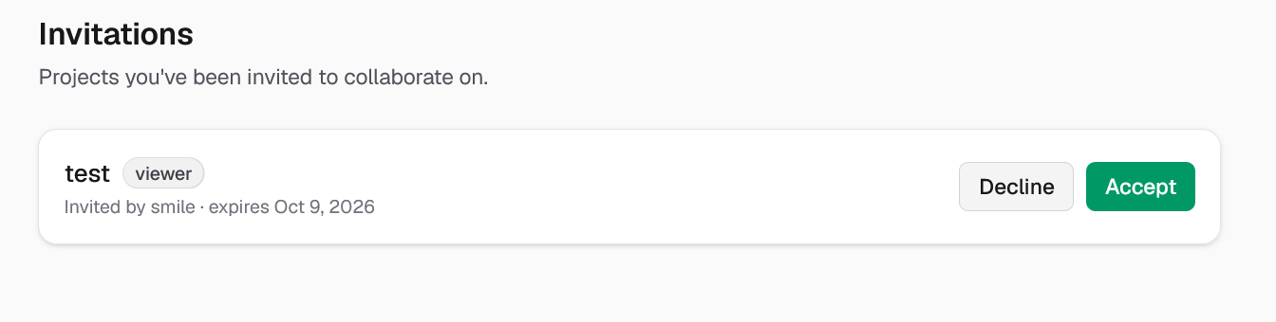
Figure 35: My invitations page

6.16 Account Settings
The Settings page, reached from the account menu, is organized into four sections.
6.16.1 Profile
Lets you choose an avatar colour and set an optional Display name. Your Username and Email are shown read-only — the username is what you sign in with and cannot be changed, and every account on the platform is always verified, so no separate verification badge or step applies here. Click "Save changes" once you have made an edit.
6.16.2 Password
Lets you change your password by entering your Current password and a New password (entered twice to confirm). Changing your password signs you out of every device, including the one you used to change it — you will need to sign in again with the new password.
6.16.3 Notifications
Two checkboxes control optional email notifications and are saved the instant you toggle them: "Test run finished" (an email when a run you started completes or fails) and "Project invitations" (an email when someone invites you to a project — invitations still appear inside the application either way). Security emails — verification codes, password-reset links, and password-change confirmations — are always sent and cannot be turned off.
6.16.4 Deleting Your Account
The Danger Zone section offers "Delete my account". Since deleting your account also deletes every project you own — along with its specification, test runs, and captured requests, and removes your teammates' access to them — the confirmation dialog states exactly how many owned projects will be lost, and requires your current password before proceeding. This action cannot be undone.
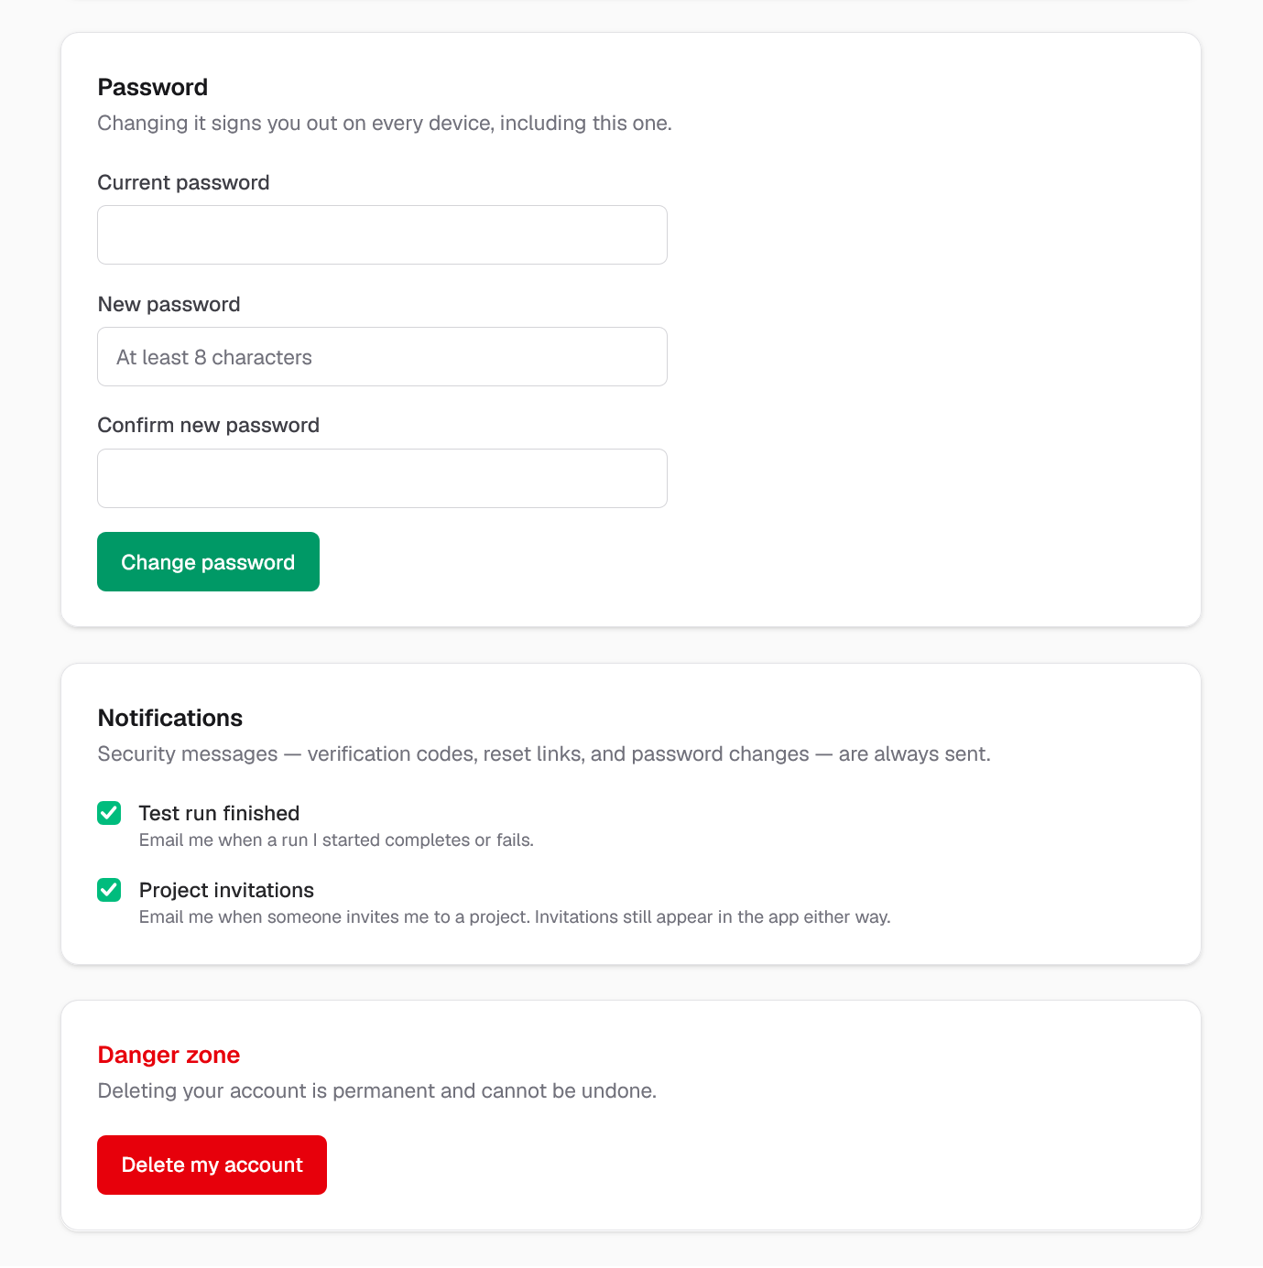
Figure 35: Account settings page

6.17 Logging Out
To end your session, open the account menu from your avatar in the top bar and click "Sign out". You are returned to the Login page.

6.18 Frequently Asked Questions
Q: I registered but never got my six-digit code. What should I do?
A: Use the "Resend the code" link on the verification screen — it is available again 60 seconds after the previous send. If the address was mistyped, use "Sign up again" to restart with the correct one.
Q: Why can't I change my username?
A: A username is the identity you sign in with, so AutoRestTest treats it as permanent once an account is created. You can still set a separate Display name in Settings, which is what teammates see around the app.
Q: Generating a specification from my source code is taking a very long time. Is something wrong?
A: Not necessarily. The pipeline reads your source code and calls an AI model to infer the specification, and large codebases can take a long time end-to-end. The page updates automatically, so it is safe to leave and come back later. Excluding vendored and build directories in the Exclude directories field before starting makes it noticeably faster.
Q: My completed run shows some 4xx responses. Is that a failure?
A: Not on its own. AutoRestTest treats a 4xx response as the API correctly rejecting a request it considered invalid — it is only counted as a fault when the API returns a 5xx server error, which indicates the API failed to handle the request at all.
Q: What is the difference between rebuilding a run and replaying it?
A: Re-running a pending run for the first time uses the AI engine to generate new requests. "Replay", available on a completed run, instead resends that exact same set of previously captured requests, in the same order, as a new run with no new generation — useful for confirming whether a fix actually resolved a fault.
Q: I accidentally deleted a project, a test run, or an endpoint. Can I get it back?
A: No. Every delete in AutoRestTest is permanent and cannot be undone, which is why each one asks for confirmation first. Make sure you mean to delete something before confirming.
Q: Can I invite someone who doesn't have an AutoRestTest account yet?
A: Yes. An invitation is sent to an email address, not an existing account; the recipient can register (or sign in, if they already have an account under that address) and then find the invitation waiting on their own "Invitations" page.
Q: Why is the "Run" button disabled on a captured request?
A: Resending a live request is limited to project Admins and Testers. Viewers can see every captured request but cannot trigger new ones against the live target API.

7. Test Report

7.1 Testing Strategy Overview
To ensure the reliability, architectural integrity, data security, and operational correctness of AutoRestTest, a comprehensive two-tier testing methodology was established and executed throughout the development lifecycle:
1. Automated Unit & Component Testing: Continuous, test-driven verification targeting the isolated logic of services, controllers, guards, algorithms, and microservice runners across both the application backend and the AI engine service.
2. System & Black-Box Acceptance Testing: Scenario-driven end-to-end testing across 7 functional modules, validating real-world workflows, permission boundaries, asynchronous states, and failure recovery on the deployed platform.
Across both tiers, a total of 352 tests (302 automated unit tests and 50 system test cases) were executed, achieving a 100% pass rate with zero defects or regressions.

7.2 Automated Unit Testing
Automated unit testing forms the backbone of the platform's verification, guaranteeing that regressions are caught immediately during development and continuous integration.

7.2.1 Backend Application Server Unit Testing (NestJS + Jest)
The core backend server is tested using Jest alongside @nestjs/testing. A total of 21 test suites comprising 257 automated unit tests verify business logic, cryptographic handlers, JWT session lifecycle, role-based access rules, OpenAPI specification parsers, and report generators. External dependencies such as SMTP mail transport, the database layer, and external LLM endpoints are isolated via mock providers to ensure rapid, deterministic test execution.
Test Suite / Service | Test Specification File | Test Cases | Scope & Logic Verified | Status
Authentication Service | auth.service.spec.ts | 14 | Login authentication, password verification, session issuance | PASS
Signup Service | signup.service.spec.ts | 12 | User registration validation, 6-digit confirmation code hashing | PASS
Token Service | tokens.service.spec.ts | 9 | JWT issuance, token refresh, cryptographically signed cookies | PASS
JWT Strategy & Guard | jwt.strategy.spec.ts | 6 | Bearer token extraction, authorization header validation | PASS
Invitations Service | invitations.service.spec.ts | 16 | Invite dispatch, 7-day expiration, token revocation, acceptance | PASS
Members Service | members.service.spec.ts | 13 | Role assignment (Admin, Tester, Viewer), permission revoking | PASS
Project Access Service | project-access.service.spec.ts | 11 | Multi-tenant isolation, ownership guard, unauthorized access blocks | PASS
Email Service | email.service.spec.ts | 10 | Resend integration, mock fallback mode, template formatting | PASS
Endpoint Extractor | endpoint-extractor.spec.ts | 12 | OpenAPI 3.0 path/method extraction, HTTP verb normalization | PASS
Endpoints Service | endpoints.service.spec.ts | 15 | Manual endpoint creation, schema persistence, safe deletion | PASS
Engine Service Client | engine.service.spec.ts | 14 | Microservice REST transport, health probes, retry & error logic | PASS
Graph Merge Algorithm | graph-merge.spec.ts | 11 | SPDG node/edge union, dependency resolution, weight updating | PASS
LLM Settings Service | llm-settings.service.spec.ts | 8 | Multi-provider configuration (NVIDIA, Gemini), key encryption | PASS
LLM Reporting Service | llm.service.spec.ts | 10 | Structured JSON prompt formatting, failure classification | PASS
Report Export Service | report-export.spec.ts | 12 | PDF rendering, CSV formatting, status code aggregation | PASS
Reports Service | reports.service.spec.ts | 18 | Coverage computation, error breakdowns, run analytics | PASS
Spec Generation Service | spec-generation.service.spec.ts | 16 | OOPS job dispatching, zip extraction, security validation | PASS
Specification Service | specs.service.spec.ts | 14 | OAS 3.0 YAML/JSON validation, versioning, replacement | PASS
Request Descriptions | request-descriptions.service.spec.ts | 12 | Natural-language explanation generator, batching logic | PASS
Test Suites Service | test-suites.service.spec.ts | 24 | Suite configuration, custom headers, run orchestration | PASS
Users Service | users.service.spec.ts | 10 | Profile updates, password alteration, account deletion | PASS
Total Backend Unit Tests | 21 Suites | 257 | Complete backend domain, security, and data layers | 100% PASS

7.2.2 AI Engine Microservice Unit Testing (Python + Pytest)
The Python engine microservice features 3 comprehensive test modules containing 45 automated tests executed using pytest. These tests validate the microservice's API endpoints, asynchronous job scheduling, proxy request interception, and MARL testing pipeline:
Test Module | Test File | Test Cases | Scope & Logic Verified | Status
Engine REST API | tests/test_api.py | 8 | Health checks, run creation, bearer authentication, job queries | PASS
Spec Generation (OOPS) | tests/test_generation.py | 18 | Zip archive handling, file filtering, timeout enforcement, rate limits | PASS
Engine Runner & Proxy | tests/test_runner.py | 19 | Job runner process lifecycle, proxy request capture, mock mode execution | PASS
Total Engine Microservice | 3 Suites | 45 | Engine REST API, runner worker, and code generation | 100% PASS

7.2.3 Automated Testing Summary
The entire suite of 302 unit tests executes in approximately 37 seconds in continuous integration:
Component | Framework | Test Suites | Total Tests | Passed | Failed | Pass Rate | Execution Time
Backend Application Server | Jest (@nestjs/testing) | 21 | 257 | 257 | 0 | 100% | 23.39s
AI Engine Microservice | Pytest (pytest-8.3.4) | 3 | 45 | 45 | 0 | 100% | 13.96s
Total Automated Unit Tests | - | 24 | 302 | 302 | 0 | 100% | 37.35s

7.3 System & Black-Box Testing
In addition to automated unit tests, extensive system-level black-box testing was conducted against the fully deployed AutoRestTest platform. A total of 50 formal test cases were evaluated across seven core functional modules to validate complete user journeys, interface behavior, security barriers, and asynchronous run execution.
Module | Module Name | Test Cases | Primary Scope | Status
Module 1 | Authentication system | 13 | Registration, email verification, login, password recovery | PASS
Module 2 | Project Management | 3 | Project creation, dashboard organization, safe deletion | PASS
Module 3 | API Specification Management | 12 | Spec upload, validation, AI generation, dependency graph | PASS
Module 4 | Test Suite Management | 4 | Run configurations, custom headers, endpoint exclusion | PASS
Module 5 | Test Execution | 6 | One-click execution, live status, request inspection | PASS
Module 6 | Test Results & Reports | 5 | Run reports, AI explanations, replay, history comparison | PASS
Module 7 | Team Collaboration | 7 | Email invitations, token security, RBAC enforcement | PASS
Total | 7 Functional Modules | 50 | End-to-end application lifecycle and security | 100% PASS

Module 1: Authentication system
Test Case 1: User Registration with Valid Details
Test Scenario: A new user signs up for AutoRestTest for the first time.
Steps:
- Open the registration page and enter a username, an email address, and a password of at least eight characters.
- Submit the registration form.
- Check the system for a newly created account.
Expected Outcome:
- The system accepts the request and tells the user that a six-digit confirmation code has been sent to their email address.
- No account has been created yet. The attempt is held aside as a pending signup, with the password already stored in a secure, unreadable form and the code stored only as a hash.
- No login session is issued at this stage, so an unconfirmed address gains no access to the platform.
Result: Pass.
Test Case 2: User Registration with Invalid or Missing Fields
Test Scenario: A user submits the registration form with information that does not meet the platform's rules.
Steps:
- Submit the form with a two-character username.
- Submit again with a username containing a hyphen.
- Submit again with a five-character password.
- Submit again leaving the email address blank.
Expected Outcome:
- Each attempt is rejected immediately with a clear, field-specific message: the username must be at least three characters, may contain only letters, numbers and underscores; the password must be at least eight characters; a valid email address is required.
- No pending signup is written for any of the rejected attempts.
Result: Pass.
Test Case 3: Registration with an Already Registered Email or Username
Test Scenario: A user tries to sign up using an email address or username that already belongs to a confirmed account.
Steps:
- Complete registration and confirmation for the username "tester01".
- Register again using the same email address.
- Register once more using the same username but a different email address.
Expected Outcome:
- Both later attempts are rejected.
- The system says clearly which value is taken - "Email is already registered" or "Username is already taken".
- The existing account is unaffected.
Result: Pass.
Test Case 4: Re-registering an unconfirmed email address
Test Scenario: Someone registers with an email address they do not own, and later the real owner of that address signs up.
Steps:
- Register with owner@example.com and never confirm the code.
- Register again with owner@example.com using a different username and password.
- Confirm using the code from the second email.
Expected Outcome:
- The second registration is accepted rather than rejected as a duplicate.
- It replaces the first pending signup, so only the second code works.
- The account is created for whoever could actually read the inbox.
- An unconfirmed address never permanently claims an email address on the platform.
Result: Pass.
Test Case 5: Email Confirmation with the Correct Code
Test Scenario: A newly registered user confirms their address with the code they received.
Steps:
- Read the six-digit code from the confirmation email.
- Enter the email address and the code on the confirmation screen.
Expected Outcome:
- The account is created and the pending signup is removed, both in a single step so a half-created account is not possible.
- A login token is returned together with the user's profile, in exactly the same shape as a normal login.
- The user lands on the dashboard already signed in.
Result: Pass.
Test Case 6: Email Confirmation with a Wrong Code
Test Scenario: A user mistypes the confirmation code repeatedly.
Steps:
- Submit an incorrect six-digit code.
- Repeat with different incorrect codes up to five times.
- Try once more with the correct code.
Expected Outcome:
- Every wrong attempt is rejected and the number of remaining attempts is tracked.
- On the fifth wrong attempt the pending signup is destroyed and the user is told to register again.
- The correct code no longer works afterwards, and no account was ever created.
Result: Pass.
Test Case 7: Login with Wrong Password or Unknown Account
Test Scenario: Someone attempts to sign in with credentials that do not match.
Steps:
- Enter a valid email address with the wrong password.
- Enter an email address that has never registered.
Expected Outcome:
- Both attempts are denied.
- Both return exactly the same generic message, so the response does not reveal whether an account exists for that address.
Result: Pass.
Test Case 8: Password Reset
Test Scenario: A user forgets their password and resets it from the emailed link.
Steps:
- Request a reset for a registered email address.
- Open the emailed link and set a new password.
- Try to sign in with the old password, then with the new one.
- Try to use a session token that was issued before the reset.
Expected Outcome:
- A reset link is emailed and expires after thirty minutes; the secret is stored only as a hash, never in readable form.
- The new password works and the old one is refused.
- Every session created before the reset is rejected, so a stolen token cannot survive a password reset.
- The reset link cannot be used a second time.
Result: Pass.
Test Case 9: Password Reset for an Unknown Email
Test Scenario: Someone requests a reset for an address that has no account.
Steps:
- Submit a reset request for an address that was never registered.
Expected Outcome:
- The response is the same neutral message shown for a registered address.
- The reset form cannot be used to discover which addresses have accounts on the platform.
Result: Pass.
Test Case 10: Update Display Name and Avatar Colour
Test Scenario: A signed-in user personalises their profile.
Steps:
- Open Settings and change the display name.
- Pick a different avatar colour and save.
- Clear the display name and save again.
Expected Outcome:
- Both changes are saved and appear immediately in the header without a reload.
- Clearing the display name falls back to showing the username.
Result: Pass.
Test Case 11: Change Password
Test Scenario: A user changes their password from the settings page.
Steps:
- Enter the current password and a new one, and save.
- Try again with an incorrect current password.
- Try setting the new password to the value it already has.
- Use a session token that was issued before the change.
Expected Outcome:
- The valid change succeeds and a security notice is emailed to the account holder.
- A wrong current password is refused with "Current password is incorrect."
- Reusing the same password is refused.
- Sessions created before the change stop working.
Result: Pass.
Test Case 12: Notification Preferences
Test Scenario: A user turns off the two optional email notifications.
Steps:
- Switch off "run finished" and "invitation" emails and save.
- Complete a test run and have another user send an invitation.
- Change the password from the settings page.
Expected Outcome:
- Preferences are saved and reflected on reload.
- Neither optional email is sent any more.
- Security notices and confirmation or reset emails are still delivered, because those cannot be switched off.
Result: Pass.
Test Case 13: Delete Account
Test Scenario: A user permanently closes their account.
Steps:
- Press Delete account and submit without a password.
- Submit with an incorrect password.
- Submit with the correct password.
- Try to sign in afterwards, and check a project the user had run tests in for someone else.
Expected Outcome:
- The first two attempts are refused: a valid session alone is not enough for an irreversible action.
- On the correct password, the account and everything it owns is removed.
- Signing in afterwards fails.
- Runs the user triggered inside other people's projects are preserved, with the attribution simply cleared.
Result: Pass.

Module 2: Project Management
Test Case 14: Create a Project
Test Scenario: A user creates a workspace to hold an API under test.
Steps:
- Open the dashboard and press New project.
- Enter a name and a description and create it.
Expected Outcome:
- The project is created with the creator as its owner and also recorded as a project administrator.
- It appears on the dashboard immediately, ready to receive a specification.
Result: Pass.
Test Case 15: Project Access Control
Test Scenario: An unrelated account tries to open someone else's project.
Steps:
- Sign in as a user with no connection to a given project.
- Open that project's page directly by its URL.
- Also request a project id that does not exist at all.
Expected Outcome:
- Access to the existing project is denied because the caller is not the owner and not a member.
- A non-existent id is reported as not found.
- No project name, description, specification, or result data is revealed in either case.
Result: Pass.
Test Case 16: Delete a Project
Test Scenario: The owner permanently removes a project and everything under it.
Steps:
- As the owner, press Delete and confirm with the account password.
- Repeat as a project administrator who is not the owner.
- Repeat as the owner but with the wrong password.
- Press Delete repeatedly in a short period.
Expected Outcome:
- The owner's confirmed deletion removes the project together with its specification, endpoints, runs, captured requests, members and invitations.
- An administrator who is not the owner is refused, and so is a wrong password.
- Repeated attempts are throttled after five in fifteen minutes.
Result: Pass.

Module 3: API Specification Management
Test Case 17: Upload a Valid OpenAPI 3.0 Specification
Test Scenario: A user uploads the API contract that the platform will test against.
Steps:
- Open the project's Specification tab and upload a valid OpenAPI 3.0 YAML file.
- Repeat with the equivalent JSON file.
- Open the Endpoints tab.
Expected Outcome:
- Both files are accepted and stored, and the API title and OpenAPI version are shown.
- Every path and method pair in the document is extracted and listed as an endpoint, with the operation summary used as its description.
- The endpoint count on the specification page matches what the Endpoints tab shows.
Result: Pass.
Test Case 18: Upload a Malformed Specification
Test Scenario: A user uploads a file that cannot be understood as an OpenAPI document.
Steps:
- Upload a file with broken YAML indentation.
- Upload a specification containing a reference that does not resolve.
- Upload an empty file.
Expected Outcome:
- Each file is rejected with a specific message explaining what is wrong, rather than a generic error.
- The project's existing specification and endpoints are left exactly as they were.
Result: Pass.
Test Case 19: Replace an Existing Specification
Test Scenario: A user uploads a newer version of the API contract over an existing one.
Steps:
- Upload a specification, add one endpoint manually, and build the dependency graph.
- Upload a different specification over it.
- Check the Endpoints and Dependencies tabs, and then an earlier completed run.
Expected Outcome:
- The new specification and its endpoints appear together, never a new specification with stale endpoints.
- Endpoints from the previous specification, including the manually added one, are cleared.
- The dependency graph built from the old specification is removed rather than shown as if it were current.
- Results of runs that have already been completed are untouched and still readable.
Result: Pass.
Test Case 20: Specification Permissions
Test Scenario: Members of different roles attempt to change the project's specification.
Steps:
- As a viewer, attempt to upload and then to delete the specification.
- As a tester, attempt the same.
- As a project administrator and as the owner, attempt the same.
- As a viewer, simply open the stored specification.
Expected Outcome:
- Only the owner and project administrators can upload or delete a specification.
- Testers and viewers are refused with a permission message.
- Viewers can still read the stored specification, so read access is not affected.
Result: Pass.
Test Case 21: Generate a Specification from a Source Archive
Test Scenario: A user has a REST API project but no OpenAPI document, and asks the platform to produce one from the source code.
Steps:
- On the Specification tab choose "Generate from source".
- Upload a .zip archive of the API's source code, optionally setting a title, version and extra directories to ignore.
- Start the generation and watch the progress panel.
Expected Outcome:
- The job is accepted and queued, and the panel shows the pipeline advancing through its nine steps.
- The generation runs on its own queue, so a test run started at the same time is not blocked behind it.
- When it finishes, the generated OpenAPI document is presented for review rather than applied automatically.
Result: Pass.
Test Case 22: Reject an Invalid or Unsafe Source Upload
Test Scenario: A user uploads something the generator should not accept.
Steps:
- Upload a .tar.gz archive instead of a .zip.
- Upload a .zip larger than fifty megabytes.
- Upload a .zip containing an entry with a "../" path, and another containing a symbolic link.
Expected Outcome:
- The non-zip archive is rejected with a message asking for a .zip.
- The oversized archive is rejected against the stated fifty-megabyte limit.
- The unsafe archives are refused during extraction, and nothing is written outside the job's own working directory.
Result: Pass.
Test Case 23: Review and Apply a Generated Specification
Test Scenario: A user reviews the generated document and adopts it as the project's specification.
Steps:
- Inspect the generated document in the review panel.
- Press Apply.
- Open the Endpoints tab and the Specification tab.
Expected Outcome:
- The generated document is validated to exactly the same standard as an uploaded one before it is accepted.
- It becomes the project's specification, clearly marked as AI-generated.
- Its operations are extracted into endpoints, and the generation record is cleared.
- Nothing is replaced until Apply is pressed.
Result: Pass.
Test Case 24: Add an Endpoint Manually
Test Scenario: A user adds an operation that is not (or not yet) in the specification.
Steps:
- Add POST /internal/health with a short description.
- Open the run configuration form.
Expected Outcome:
- The endpoint is created, marked as manually added, and listed alongside the extracted ones.
- It is immediately available when configuring a test run.
Result: Pass.
Test Case 25: Delete an Endpoint
Test Scenario: A user removes an endpoint they no longer want tested.
Steps:
- As the owner or a project administrator, delete a manually added endpoint.
- As a tester, attempt the same.
- Configure a new run afterwards.
Expected Outcome:
- The owner or administrator deletion succeeds and the row disappears from the list.
- The tester is refused with a permission message.
- The deleted endpoint no longer appears when configuring a run.
Result: Pass.
Test Case 26: Build the Project Dependency Graph
Test Scenario: A user asks the platform to work out how the API's operations depend on each other.
Steps:
- Open the project's Dependencies tab and press Build.
- Watch the status while the build runs.
- Read the summary line once it completes.
Expected Outcome:
- The build is queued on the engine and the page tracks it until it is ready, without the user having to reload.
- On completion the view reports how many operations and how many resolved dependencies the graph holds.
- The build uses only the stored specification: no test run, no live API and no AI call is required.
Result: Pass.
Test Case 27: Inspect One Operation's Dependencies
Test Scenario: A user examines which operations feed into a given operation and which consume its output.
Steps:
- Choose an operation from the list beside the diagram.
- Read the diagram and the labels on the arrows.
- Note the order in which the operations are listed and which one is selected first.
Expected Outcome:
- The diagram shows the operations that can supply this one's parameters on one side, the selected operation in the middle, and the operations that consume its response on the other.
- Each arrow is labelled with the parameter that connects the two operations.
- The list is ordered by how many connections each operation has, and opens on the most connected one, so the operations worth looking at are not buried alphabetically.
Result: Pass.
Test Case 28: Dependency Graph Attached to a Completed Run
Test Scenario: A user views the graph as it stood for a particular test run, with what the engine learned about it.
Steps:
- Open a completed run and view its dependency graph.
- Compare the weight shown on each dependency with the run's behaviour.
- Open a run recorded before the graph feature was revised.
Expected Outcome:
- The run shows the graph that produced its results, even if the project's specification has since changed.
- Each dependency carries the weight the reinforcement-learning agent assigned to it during that run.
- An older run's stored graph is re-resolved when it is read, so old and new runs display in the same, readable form.
Result: Pass.

Module 4: Test Suit Management
Test Case 29: Configure a Test Run
Test Scenario: A user sets up a run of the AI testing engine against a live API.
Steps:
- Press New run and give the run a name.
- Enter the target base URL, a time budget in seconds and a mutation rate.
- Save the configuration.
Expected Outcome:
- The run record is created in a pending state with exactly the settings entered.
- It appears at the top of the project's run list, ready to be started.
Result: Pass.
Test Case 30: Custom Authentication Headers
Test Scenario: A user configures a run against an API that requires authentication.
Steps:
- Open the Advanced section of the run form.
- Add an Authorization header carrying a Bearer token, and a second API-key header.
- Save the run, then reopen it and inspect the run detail returned by the platform.
- Start the run and inspect the captured requests.
Expected Outcome:
- The headers are stored and sent with every request the engine makes to the target API.
- The header values are never returned in any read response, so a credential entered once does not leak back out through the interface.
Result: Pass.
Test Case 31: Custom Header Validation
Test Scenario: A user enters header values that would be unsafe to forward.
Steps:
- Add a header whose name contains a space.
- Add a header whose value contains a line break.
- Add twenty-one headers.
Expected Outcome:
- The invalid header name is rejected.
- The value containing a line break is rejected, so a header value cannot be used to inject extra headers into the outgoing request.
- The twenty-first header is rejected against the stated limit.
Result: Pass.
Test Case 32: Excluding Endpoints from a Run
Test Scenario: A user leaves out operations that are unsafe or pointless to fuzz.
Steps:
- In the run form, mark two operations as excluded.
- Start the run and let it complete.
- Inspect the per-endpoint request summary.
Expected Outcome:
- The excluded operations are removed from the specification handed to the engine, so no request is generated for them.
- The remaining operations are tested normally.
- If an excluded endpoint has since been deleted from the project, the run still starts and simply ignores it.
Result: Pass.

Module 5: Test Execution
Test Case 33: One-Click Test Execution
Test Scenario: A user starts a configured run and follows its progress.
Steps:
- Press Run on a configured run.
- Stay on the page and watch the status without reloading.
- Navigate to another page and come back.
Expected Outcome:
- The platform hands the specification and settings to the testing engine and returns straight away, without holding the browser.
- The status moves from pending to running to completed, and the counts of endpoints covered and test cases passed and failed appear as the run finishes.
- The interface stays usable throughout, and returning to the page shows the current state rather than a stale one.
Result: Pass.
Test Case 34: Running Without a Specification, or While Already Running
Test Scenario: A user starts a run in circumstances where it cannot proceed.
Steps:
- Delete the project's specification and press Run on an existing run configuration.
- On a running run, press Run a second time.
Expected Outcome:
- The first is refused with a message asking the user to upload a specification before running a test suite.
- The second is refused with "Test suite is already running", and the live run continues undisturbed.
Result: Pass.
Test Case 35: Re-running an Existing Run
Test Scenario: A user runs the same configuration again after fixing something in the target API.
Steps:
- Open a completed run with results and captured requests.
- Press Run again and let it finish.
- Inspect the results and the captured request list.
Expected Outcome:
- The previous results, test cases and captured requests for that run record are cleared before the new execution begins.
- The displayed results always belong to the most recent execution, never a mixture of two.
Result: Pass.
Test Case 36: Per-Endpoint Request Summary
Test Scenario: A user reviews how many requests a run sent to each operation and how they turned out.
Steps:
- Open a completed run's request list.
Expected Outcome:
- Each endpoint has one row showing how many requests were sent to it and how those split across the 2xx, 3xx, 4xx and 5xx response classes.
- Requests that did not match any known operation are collected in a separate bucket, which is itself a finding: it means the engine mutated the HTTP method.
- Matched endpoints are listed first, with the unmatched bucket last.
Result: Pass.
Test Case 37: Browse and Filter Captured Requests
Test Scenario: A user drills into one endpoint's requests and narrows them down.
Steps:
- Open one endpoint's captured requests.
- Page through the list.
- Filter by one specific response code from the dropdown.
- Copy the resulting URL and open it in a new tab.
Expected Outcome:
- Requests are listed in the order they were sent and are paginated so a run with thousands of requests still loads quickly.
- The response-code filter offers only the codes this run actually produced, and returns exactly the matching requests.
- The filtered view reopens unchanged from its URL, so a particular view can be shared with a teammate.
Result: Pass.
Test Case 38: Inspect a Single Request and Response
Test Scenario: A user examines exactly what was sent and what came back.
Steps:
- Open one captured request from the list.
Expected Outcome:
- The full request is shown as it was sent: method, URL, headers and body.
- The full response is shown as it was received: status code, headers, body and how long it took.
- A body too large to store in full is clearly marked as truncated, rather than presented as if it were complete.
Result: Pass.

Module 6: Test Results & Reports
Test Case 39: Explain Requests
Test Scenario: A user asks the platform to describe, in plain language, what each generated request was testing.
Steps:
- Open a completed run and press "Explain requests".
- Wait for the pass to finish, watching the progress indicator.
- Read the Description column in the request list.
Expected Outcome:
- Each request gains a single plain sentence describing what it tests, for example "Sends a title longer than the declared 50-character maximum".
- Progress is reported as the pass runs, and it continues automatically until every request has been described.
- Descriptions state the intent of the test, so the same request reads the same way whether it passed or failed.
Result: Pass.
Test Case 40: View a Run Report
Test Scenario: A user reviews the outcome of a completed run.
Steps:
- Open the report for a completed run.
Expected Outcome:
- The overview shows how many endpoints were covered out of the total and as a percentage, the pass rate, the total, passed and failed test-case counts, and how long the run took.
- The distribution of response codes across the whole run is shown.
- Per-endpoint outcomes are listed, with a separate list of failures and a flag on any endpoint that produced server errors.
Result: Pass.
Test Case 41: Explain Failures
Test Scenario: A user asks for plain-language explanations of the run's failures.
Steps:
- Press "Explain failures" on a run with failures.
- Wait for the explanations to appear.
- Press it a second time.
Expected Outcome:
- Each failed endpoint gains a short explanation of the likely cause, written in plain language.
- The second press reuses explanations already produced and only fills in the ones still missing, so an interrupted first attempt can simply be repeated.
Result: Pass.
Test Case 42: Replay a Completed Run
Test Scenario: A user re-sends a recorded run's exact request sequence to check whether the API still behaves the same way.
Steps:
- Press Replay on a completed run.
- Watch the replay run to completion.
- Return to the original run.
Expected Outcome:
- A new run is created, marked as a replay, and the original run's captured requests are re-sent in their recorded order against the target.
- No AI generation is involved, so the replay is a deterministic regression check rather than a fresh set of tests.
- The original run's results are never overwritten, and both runs remain available side by side.
Result: Pass.
Test Case 43: Run History and Comparison
Test Scenario: A user compares a run against its replays to spot a regression over time.
Steps:
- Open the history panel for a run that has several replays.
- Read the pass and fail counts along the timeline.
Expected Outcome:
- The original run and every replay of it are listed oldest first, each with its outcome counts.
- A change in behaviour between two points in time is visible at a glance, because every entry sends the same fixed request sequence.
Result: Pass.

Module 7: Team Collaboration
Test Case 44: Invite a Collaborator
Test Scenario: A project administrator brings a teammate into the project.
Steps:
- Open the Team tab and invite an email address with the tester role.
- Check the invitation list and the invited person's inbox.
Expected Outcome:
- A pending invitation is created with a unique token, valid for seven days.
- An invitation email is sent to the address, and the invitation is listed as pending on the Team tab.
Result: Pass.
Test Case 45: Accept an Invitation
Test Scenario: An invited user joins the project.
Steps:
- Sign in as the invited user and open the Invitations page.
- Accept the invitation.
- Open the project.
Expected Outcome:
- The user becomes a member with exactly the role they were invited with, no more.
- The invitation is marked accepted, and the project appears in the user's project list.
Result: Pass.
Test Case 46: Invitation Security and Expiry
Test Scenario: Someone tries to use an invitation that is not theirs, or is no longer valid.
Steps:
- While signed in as one account, attempt to accept an invitation addressed to a different email address.
- Attempt to accept an invitation that has passed its seven-day expiry.
- Attempt to accept an invitation that has already been accepted or declined.
Expected Outcome:
- The wrong recipient is refused, so an invitation link alone is not enough to join a project.
- ·An expired invitation is refused with a message saying so.
- An invitation that has already been resolved cannot be used again.
Result: Pass.
Test Case 47: Resend, Revoke and Decline an Invitation
Test Scenario: An administrator manages outstanding invitations, and an invitee turns one down.
Steps:
- Resend a pending invitation.
- Revoke a different pending invitation and try its link afterwards.
- As an invitee, decline a third invitation.
Expected Outcome:
- Resending re-sends the email for the same invitation, and reports clearly if the email could not be sent.
- A revoked invitation is removed and its link no longer works.
- A declined invitation is marked declined and creates no membership.
Result: Pass.
Test Case 48: Role Enforcement: Viewer
Test Scenario: A viewer confirms they can read everything and change nothing.
Steps:
- As a viewer, attempt to upload a specification, add an endpoint, configure a run, start a run, replay a run, build a dependency graph, re-run a single captured request, and invite a member.
- As the same viewer, open the specification, endpoints, dependency graph, run results, captured requests and reports.
Expected Outcome:
- Every attempt to change something is refused with a permission message.
- Every read succeeds, so a viewer is a genuinely useful read-only role rather than a locked-out one.
Result: Pass.
Test Case 49: Role Enforcement: Tester and Administrator
Test Scenario: A tester and an administrator confirm the boundary between their roles.
Steps:
- As a tester, configure and start a run, replay it, re-run a single captured request, build the dependency graph and request explanations.
- As the same tester, attempt to upload a specification, delete a run, delete an endpoint and manage members.
- Repeat both groups as a project administrator.
- As a project administrator, attempt to delete the project.
Expected Outcome:
- The tester can do everything in the first group and is refused for everything in the second.
- The administrator can do both groups.
- Deleting the project remains with the owner alone, even for an administrator.
Result: Pass.
Test Case 50: Manage Members
Test Scenario: An administrator adjusts the team, and a member leaves.

Steps:
- Change a member's role from viewer to tester.
- Remove a member from the project.
- As a member, leave the project.
- As the owner, attempt to leave.
Expected Outcome:
- The role change takes effect on the member's very next action.
- A removed member loses access to the project immediately.
- A member can leave on their own initiative.
The owner is told to delete the project instead of leaving it, so a project is never left without an owner.
Result: Pass.

8. Real-World Evaluation

8.1 Overview
To evaluate the practical effectiveness of the AutoRestTest platform, an empirical evaluation was conducted against 15 real-world REST API projects. The primary objective of this evaluation was to validate the platform's ability to autonomously parse OpenAPI specifications, resolve complex data dependencies using the Semantic Property Dependency Graph (SPDG), and leverage the Multi-Agent Reinforcement Learning (MARL) and LLM-driven engine to maximize endpoint coverage and discover genuine server-side faults (5xx errors) without requiring manual test case creation.

8.1 Evaluation Methodology
For each of the 15 APIs evaluated, a systematic testing procedure was executed utilizing the AutoRestTest platform:
- Target Environment Setup: If the target project provided a live hosted platform, it was tested directly. If no live hosted platform was available, the project was self-hosted locally using Docker to ensure a stable testing environment.
- API Specification Management: The official OpenAPI Specification (OAS) file provided in the target project's source code was used for the testing.
- Execution Configuration: Test suites were configured with a time budget based on number of endpoints in the target API, generally ranging from 10 to 30 minutes.
- LLM Usage and Generation: The testing engine utilized the free LLM model provided by NVIDIA (model: nvidia/nemotron-3-super-120b-a12b), operating within a rate limit of 35 Requests Per Minute (RPM).
- Analysis: The system's generated reports were analyzed for total endpoints covered, HTTP status code distributions (2xx, 4xx, 5xx), and AI-generated failure explanations.

8.3 Evaluation Summary

Project Name | Source | Total Endpoints | Time Budget (sec) | Coverage (%) | Request Sent | Successful (2xx) | Server Error (5xx) | Faulty Endpoints
HomeLogger | https://github.com/FrancisLaboratories/homelogger | 37 | 1200 | 92% | 2208 | 1134 | 94 | 4
ApogeoAPI | https://api.apogeoapi.com/api/docs | 46 | 1200 | 93% | 496 | 249 | 10 | 3
UK Parliament Bills API | https://bills-api.parliament.uk | 22 | 1500 | 77% | 4912 | 1857 | 2 | 2
UK Parliament Members API | https://members-api.parliament.uk | 43 | 1200 | 91% | 1306 | 590 | 35 | 1
Snipe-IT | https://github.com/grokability/snipe-it | 145 | 1500 | 98% | 3162 | 2104 | 6 | 5
RealWorld | https://github.com/realworld-apps/realworld | 17 | 1200 | 88% | 949 | 230 | 0 | 0
Grocy | https://github.com/grocy/grocy | 44 | 1200 | 82% | 1198 | 414 | 152 | 20
LubeLogger | https://github.com/hargata/lubelog | 76 | 1500 | 62% | 1016 | 314 | 30 | 19
IUCN Red List | https://api.iucnredlist.org | 50 | 900 | 88% | 894 | 423 | 3 | 3
CosmyDay | https://cosmyday.com/api-docs | 17 | 1200 | 94% | 414 | 249 | 0 | 0
VATcomply | https://github.com/madisvain/vatcomply | 7 | 300 | 100% | 468 | 325 | 0 | 0
CareerStory | https://github.com/CodeWithIsmail/CareerStory-backend | 18 | 600 | 72% | 680 | 170 | 3 | 1
Laravel Blog | https://github.com/guillaumebriday/laravel-blog | 23 | 1500 | 91% | 2250 | 1235 | 10 | 4
CycleCalcs | https://www.cyclecalcs.com/api.html | 30 | 900 | 100% | 1130 | 501 | 0 | 0
Holiday | https://github.com/nager/Nager.Date | 6 | 300 | 100% | 611 | 361 | 51 | 1

8. Timeline
The estimated timeline for the AutoRestTest project is presented below:
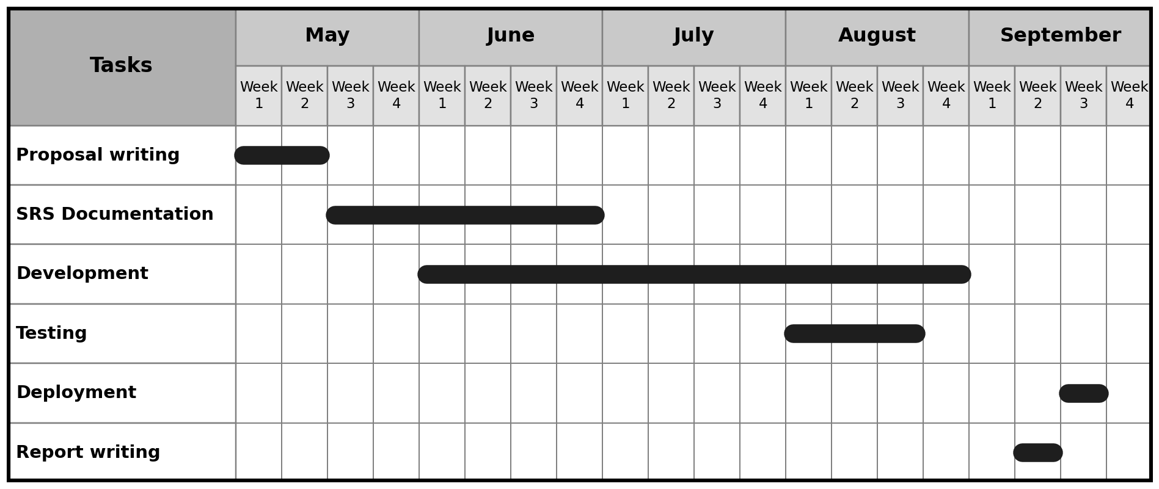
Figure 19: Timeline Gantt Chart

9. Conclusion
This report has presented the complete technical specification of AutoRestTest, an AI-powered collaborative platform for automated REST API testing. It covered the project's problem statement, objectives, scope, and deliverables; a requirements analysis through QFD, stakeholders, and usage scenarios; system and data modeling; and a preliminary test plan. Diagrams and tables have been used throughout to make the design clear. While the platform already supports the full testing workflow, it can be extended in future with support for other API paradigms (GraphQL, SOAP, gRPC), load and performance testing, and more advanced RL/LLM techniques. This document should provide a complete understanding of the requirements and technical design of AutoRestTest.

10. References
[1] Tyler Stennett, Myeongsoo Kim, Saurabh Sinha, and Alessandro Orso,
A Multi-Agent Approach for REST API Testing with Semantic Graphs and LLM-Driven Inputs, in Proceedings of 47th International Conference on Software Engineering (ICSE 2025)
Paper: https://arxiv.org/abs/2411.07098v2

